WEATHERIZATION ASSISTANCE PROGRAM

MATERIALS INSTALLATION STANDARDS



Texas Department of Housing and Community Affairs
June, 1998

FORWARD

All subgrantees shall be required to implement the TEXAS WEATHERIZATION ASSISTANCE PROGRAM MATERIALS INSTALLATION STANDARDS effective April 1, 1992. These minimum criteria are designed to ensure that all WAP clients, regardless of geographic location, receive the highest quality and most effective service possible. Providing optimum energy savings and guarding worker/client safety are also important objectives of Texas standardized weatherization materials and methods.

This manual is the product of a collaborative effort among representatives of 15 Texas subgrantees, two WAP vendors and the Energy Assistance Section staff. Members of the INSTALLATION STANDARDS COMMITTEE (listed in the ACKNOWLEDGMENTS on page 3) met several times over a number of months to produce a document which, to the greatest extent possible, recognizes the vast geographic and other differences inherent in such a large and diverse state. California’s Materials Installation Standards Manual served as the committee’s starting point, but members had virtually complete control over the Texas manual’s final content.

The committee dealt with each of the 10 sections in great detail. Point by point, there was an effort to achieve common understanding and consensus. Differences of opinion among members were resolved by a show of hands (excluding EA staff). Ultimately, each vote regarding an items inclusion, exclusion or amendment was approved by a (75% or greater) majority.

Clearly, this manual was produced through the careful, thoughtful deliberation of individuals representing all Texas Weatherization Subgrantees. Subgrantee staff who perform pre- and post- inspections are responsible for ensuring field compliance. EA program monitors will verify compliance as a part of the regular, ongoing monitoring process. Failure to meet these standards will require corrective standards.

Incorrectly installed or substandard materials must be replaced. Charges for replacement materials and/or labor are not an allowable WAP expense. When additional materials (not originally installed) are required as a corrective action, the associated materials and labor cost are allowable, so long as the total job cost (including incidental repairs) does not exceed the currently allowed maximum expenditures per WAP unit. Any costs excess of the currently allowed maximum shall be disallowed.

In order to meet the needs of the changing weatherization program, health and safety concerns, heating/cooling appliances and the requirements of the “EASY for Texas” Energy Audit, this manual was updated in October, 1997. Sections 10 and 11 have been added to provide guidance for weatherization professionals to determine heating/cooling needs and ensure indoor air quality. The attached addendum will provide guidance for performing combustion appliance safety inspections necessary for indoor air quality and the safety of the client.

This manual and it’s contents belong to the SUBGRANTEE, not to any individual employee. The subgrantee shall ensure that the manual is retained (should staff changes occur) and keep in current usable condition. TDHCA will issue revisions and new sections as needed. Revised sections shall replace previous text and new sections shall be inserted as directed. TDHCA invites and welcomes any suggestions for changes, additions or deletions.

ACKNOWLEDGMENTS

This manual was developed by weatherization field staff working in conjunction with the Department's Energy Assistance section staff.

The Department wishes to express our deepest appreciation to the individuals listed below without whom this manual would not have been possible.

Materials Installation Standards
Advisory Committee

Gene Abbott Panhandle Community Services
Bill Cox Combined Community Action, Inc.
Delores Crum Weather-Rite
Richard Crum Weather-Rite
Ben Davis Rusk-Cherokee Community Action Program, Inc.
Ken Deckard Community Action Program, Inc.
Jim Dennis Sheltering Arms, Inc.
Carlos Grajeda El Paso Community Action Program - Project Bravo
Anita Hernandez Nueces County Community Agency
Art Kampschafer Community Services, Inc.
Gary McBrayer City of Fort Worth, Housing and Human Services Dept.
Raul Perez Alamo Area Council of Governments
Sharon Perkins Travis County, Department of Housing Services
Eli Ramirez Community Action Council of South Texas
George Roe Tri-County Community Action, Inc.
Salvador Vargas Community Services Agency of Dimmit, LaSalle and Maverick Counties
Tim Whitley Hill Country Community Action Association, Inc.

TDHCA Energy Assistance Staff Participants:

Peggy Colvin Assistant Director
Rosario Cardenas Trainer
Ju-Young Vega Planner
Craig S. Baird Program Officer
Tim Baker Program Officer
Ashley Grosse Program Officer

STATE OF TEXAS
WEATHERIZATION ASSISTANCE PROGRAM
MATERIALS INSTALLATION STANDARDS

Table of Contents

Section 1 Caulking Standards

Section 2 Electrical Outlet and Switch Gasket Standards

Section 3 Weatherstripping Standards

Section 4 Door Replacement Standards

Section 5 Window and Glass Replacement Standards

Section 6 Pipe and Water Heater Insulation Standards

Section 7 Attic/Ceiling Insulation and Ventilation Standards

Section 8 Storm Window Standards

Section 9 Solar Screen Standards

Section 10 Health and Safety Standards

Section 11 Heating and Cooling Standards

Section 12 Wall Insulation Standards

Section 13 Floor Insulation Standards

SECTION 1
CAULKING STANDARDS

ITEM | MATERIALS | CRITERIA/REQUIREMENTS
1. Acceptable Materials | Acrylic latex plus silicone sealing compounds | - Conforms to ASTM with silicone ASTM C834-76
 |  | - Note: If tube states “meets performance standards,” this is not acceptable. Must have wording to the effect that the product “meets or exceeds the ASTM specification C-0834-76.”
 | Polyurethane Foam | - Conforms to ASTM-84 (commercially available)
 | Elastomeric sealants (including polysulfide, polyurethane, and silicone) | - Conforms to ASTM C920-87
NOTE: All of the above caulks shall be clear when dry and paintable.
 | Masonry compounds | - Commercially available
2. Where to Install Caulking* | For all types of caulk | - Dwelling units shall be sealed from the inside
 |  | - Interior caulking shall be applied as directed by the Blower Door Test such as:
 |  | --between baseboard and floor and between baseboard and wall
*All caulking is to be installed as directed by Blower Door tests and an SIR of 1.0 or better in the EASY Audit

SECTION 1
CAULKING STANDARDS

ITEM | MATERIALS | CRITERIA/REQUIREMENTS
2. Where to Install Caulking (continued) | For all types of caulk | --around windows, between window trim and wall surfaces, between window sill and wall and between window edge and window frame
 |  | --around exterior door (and interior doors separating conditioned from unconditioned spaces), around outer frames, between door and sill and floor
 |  | --inside kitchen and bathroom cabinets
 |  | --around attic hatchways
 |  | --around wall/window mounted air conditioners
 |  | --around plumbing and electrical penetrations
 |  | --around ceiling and ceiling penetrations
 |  | --around appliances, including washers and dryers, where electrical and/or plumbing penetrations occur
 |  | --around interior and exterior perimeter of prime and storm windows and doors

NOTE: Caulking around exterior of windows and doors is to prevent moisture penetration.

--cracks in envelope (as detailed in item 4)
--around chimneys/fireplaces
--at all other significant sites revealed during blower door testing

The determination of exterior caulking shall be left to the discretion of the assessor. The program officer will only require exterior caulking in areas where there is clear evidence that water penetration may occur.
SECTION 1
CAULKING STANDARDS

Common Draft Points

1. Between baseboard and floor and between baseboard and wall

2. Wall socket outlets and electrical switches

3. Around windows, between window trim and wall surfaces, between window sill and wall , between edges and window frame

4. Around exterior doors (and interior doors separating conditioned from unconditioned spaces), around outer frames, between door trim and wall surface and between door sill and floor

5. Inside kitchen and bathroom cabinets

6. Around attic hatchways

7. Around wall and window mounted room air conditioners

8. Around plumbing and electrical penetrations

9. Around ceilings and ceiling penetrations

10. Around appliances, especially washers and dryers

11. Around fireplaces

SECTION 1
CAULKING STANDARDS

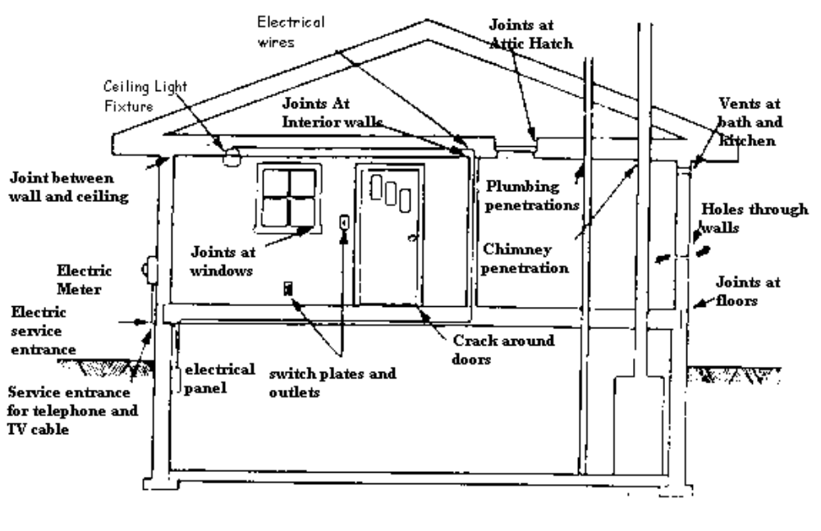
Areas where leakage occurs
SECTION 1
CAULKING STANDARDS

Hidden air leaks

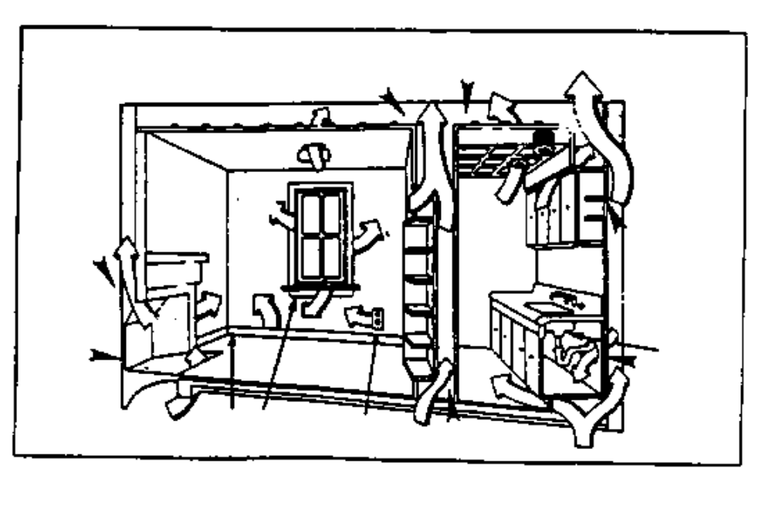

SECTION 1
CAULKING STANDARDS

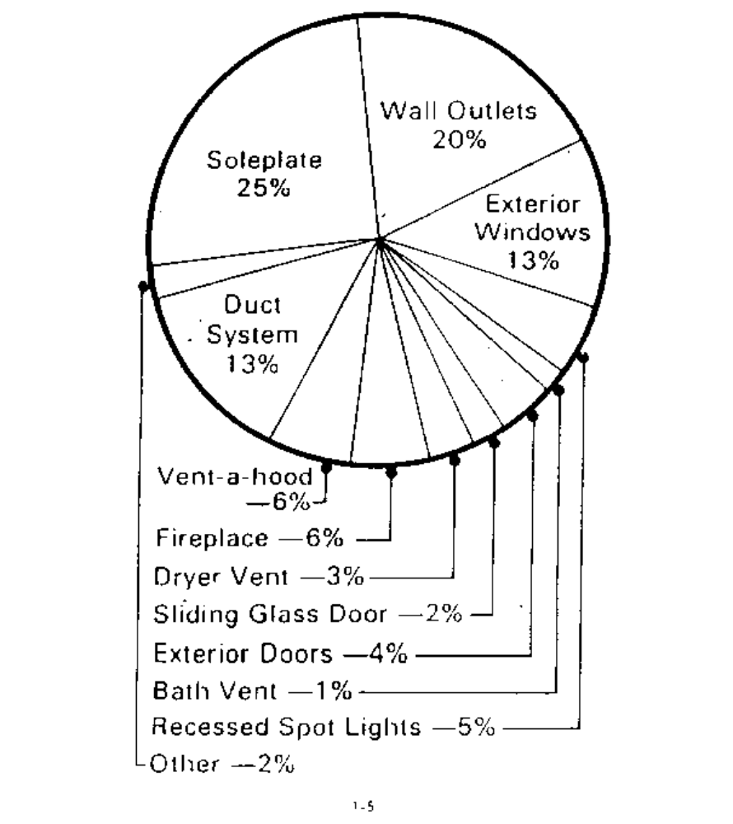

SECTION 1
CAULKING STANDARDS

ITEM | MATERIALS | CRITERIA/REQUIREMENTS
3. Finished Bead | For all types of caulk | - Beads must be continuous, free of voids and effective in eliminating the air infiltration
 |  | - All excess caulk should be removed so that a neat appearance is achieved
 |  | - All caulk shall be troweled or finger wiped after application
4. Cracks | For all types of caulk | - Interior cracks larger than 1/16” should be sealed
 |  | - Cracks larger than 1/4” should be filled before caulking (see item 5)
 |  | - Exterior cracks which allow moisture penetration should be addressed as referenced in “Interior cracks” above
 |  | - Note: Units which must be sealed solely from the outside shall use the standards referenced above for 1/16”, 1/4” and 1” cracks
 |  | - All cracks must be sealed completely

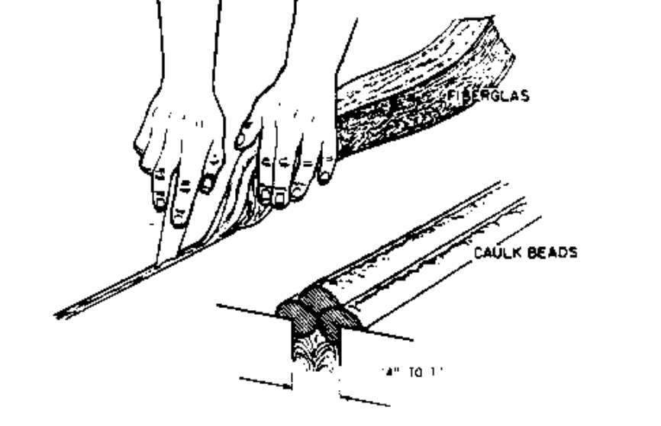
SECTION 1
CAULKING STANDARDS

ITEM | MATERIALS | CRITERIA/REQUIREMENTS
5. Filler Material | For all types of caulk | - Spaces wider than 1/4” but not wider than 1” should be filled to within at least 1/4” of the surface with one of the following:  --closed cell foam tape  --oakum  --closed cell polyethylene rod  --twine  --flexible fiberglass  --polyurethane foam
 |  | - Filler material must be covered with caulk

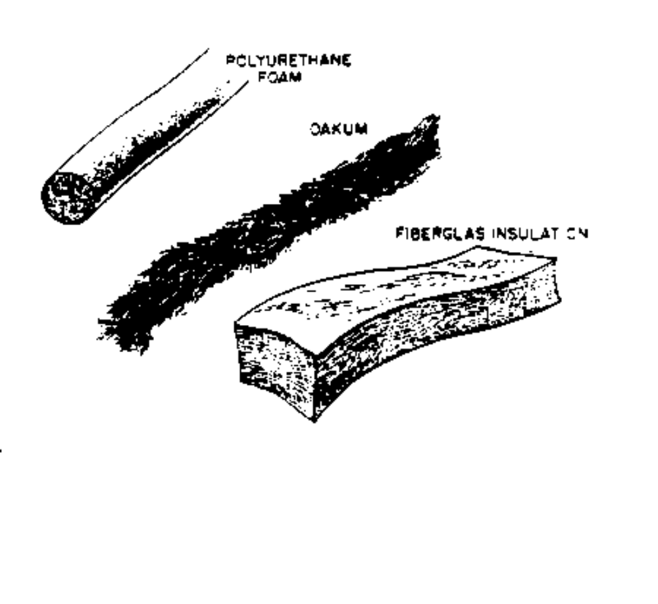

SECTION 1
CAULKING STANDARDS

ITEM | MATERIALS | CRITERIA/REQUIREMENTS
6. Surface Preparation Requirements | For all types of caulk | - Surface must be reasonably free of loose or cracked caulk
 |  | - Surface must be free of dirt and debris so that applied caulk will adhere to surface
 |  | - Surface must be free of moisture unless allowed by specifications
7. Application Requirements | For all types of caulk | - Follow manufacturer’s instructions in all cases, with careful attention to:
 |  | --Application temperature limits
 |  | --Primer requirements for masonry surfaces

Nonfeasible Criteria For Interior Caulk Application

Do Not Install:

1. When the common infiltration points (as listed) are inaccessible due to crowded, cluttered or other extremely adverse conditions

2. Where interior sheathing is improperly applied so that interior sealing is not economically feasible

3. When client refuses interior sealing (must be documented in client file folder)

4. When conditions exist in the interior of the unit which would pose a threat to the health or safety of the work crew; and

5. When not justified by a blower door test or the EASY Audit with an SIR of 1.0 or greater

(These conditions must be well documented with pictures when possible. Documentation must be maintained in the client file.)
Note: “Controlled” ventilation is essential to client health and safety. Refer to blower door standards.

SECTION 2
ELECTRICAL OUTLET AND SWITCH GASKET STANDARDS

ITEM | MATERIALS | CRITERIA/REQUIREMENTS
1. Acceptable Materials | All Types | - Must be fire resistant
 |  | - Must be pre-cut to fit
2. Where Installed  (When directed by  the EASY Audit) | All Types | - Install gaskets under all electrical plates (including telephone and cable plates) on all walls. (Exceptions to this requirement are listed under “NONFEASIBLE”)
3. Plates | All types | - Cracked or missing plates must be replaced
 |  | - Gaskets and plate must provide adequate seal to wall
 |  | - Switch or receptacle should be adjusted if necessary for seal
 |  | - Holes or gaps around electrical boxes must be sealed
 |  | - Oversized plates may be used if necessary to achieve seal

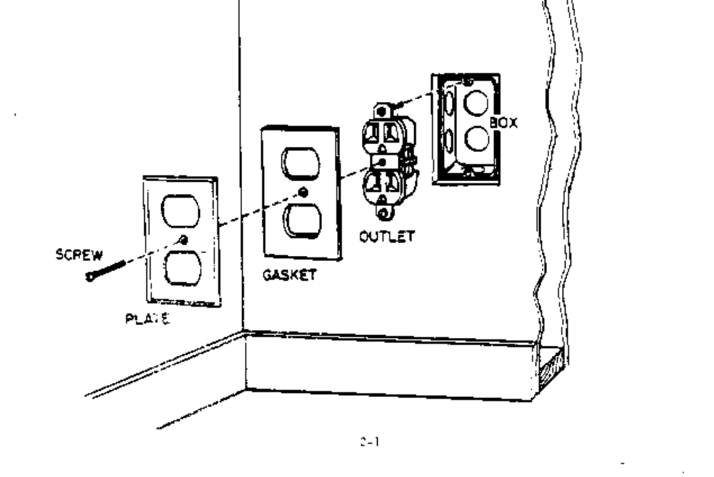

SECTION 2
ELECTRICAL OUTLET AND SWITCH GASKET STANDARDS

Nonfeasible Criteria For Electrical Outlet And Switch Gaskets

Do Not Install:

1. When already properly installed

2. When outlets/switches are located behind fragile furniture, heavy furniture, or a major appliance

3. When there is evidence of electrical malfunction (i.e., electrical box not permanently attached or signs of burning or charring)

4. Behind plates which are painted or plastered to wall

5. On surface mounted boxes

6. When sealed boxes exist (such as in mobile or modular homes)

7. When not justified by the EASY Audit with an SIR of 1.0 or greater

8. When blower door tests indicate no leakage

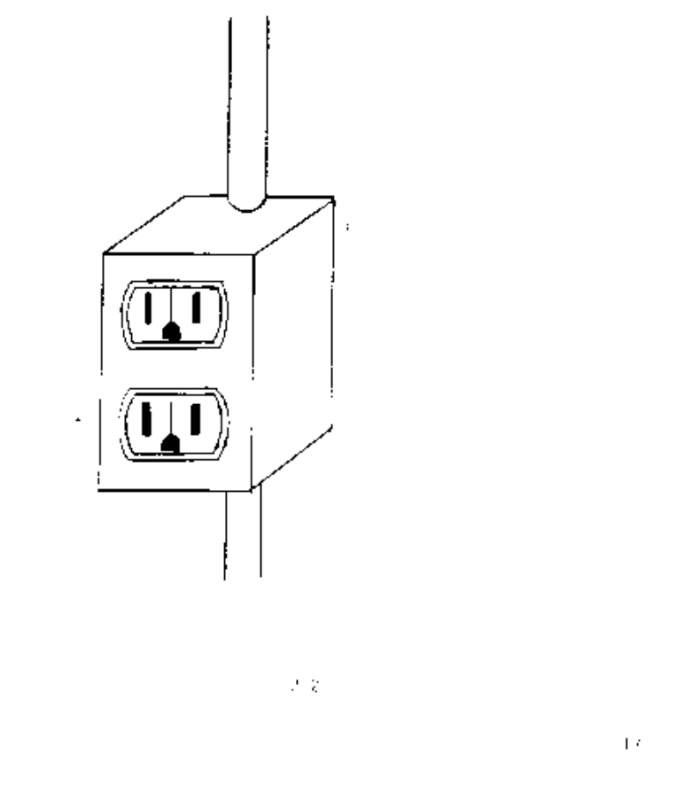
SECTION 3
WEATHERSTRIPPING STANDARDS

ITEM | MATERIALS | CRITERIA/REQUIREMENTS
1. Acceptable Materials | Foam Tape | - Must be closed cell
 |  | - Must be UV resistant
 |  | - Must have adhesive backing
 | Vinyl V-Strip | - May only be applied to surfaces thoroughly cleaned with alcohol or other cleaning solvent
 |  | - Must be affixed with siliconized sealant
 | Pile | - May replace existing material only
 | Spring and cushion metal | - Must be made from bronze
 |  | - Must be attached (nailed) every 4”
 | Rigid gasket (aluminum carrier) | - Must be adjustable and attached with screws or nails
 |  | - Gaskets must be attached to an aluminum carrier (carrier must be at least .05” thick)
 |  | - Carrier must have slotted holes no more than 9” on center
 |  | - Siliconized gasket highly recommended
 |  | - Hollow bulb style or flap style gasket acceptable
 | Q-lon | - Use to replace original material only

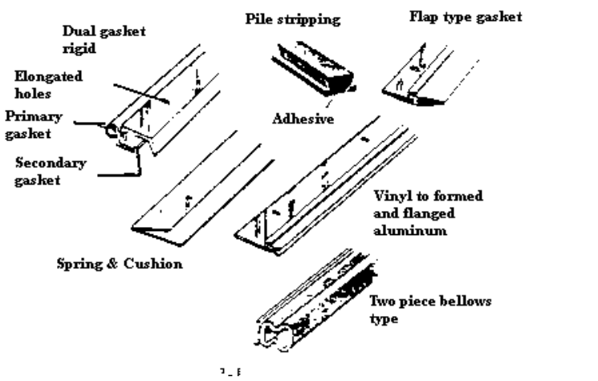
SECTION 3
WEATHERSTRIPPING STANDARDS

ITEM | MATERIALS | CRITERIA/REQUIREMENTS
2. Warranty | All types | - Must have a minimum of 1 year warranty
3. Where Installed | All types | - Must be placed at movable joints (i.e. doors and attic hatches) separating conditioned spaces from unconditioned spaces
4. Double Hung Windows | Wood, metal and plastic | - Sash locks manufactured (only)  - Shims may be used to form an effective seal
 |  | - Pulley seals will be installed where needed
 |  | - Closed cell foam may be used in compression only

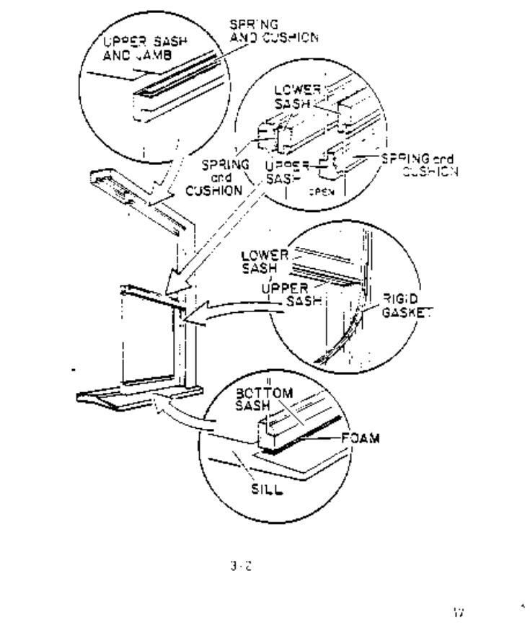

SECTION 3
WEATHERSTRIPPING STANDARDS

ITEM | MATERIALS | CRITERIA/REQUIREMENTS
5. Casement Windows | Wood, metal and plastic | - May use spring metal, cushion metal or rigid gasket
 |  | - Closed cell foam may be used in compression only
6. Horizontal Aluminum Slider | Metal | - May use replacement pile, closed cell foam, flex tape V-strip with siliconized adhesive or other effective material

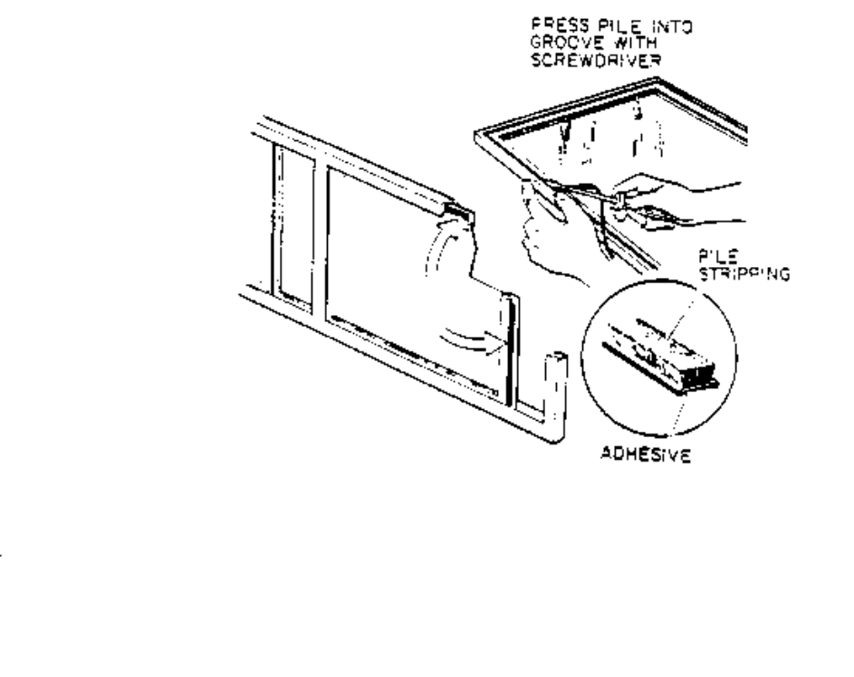

7. All Metal Window | All types | - Replacement pile recommended
 |  | - Replacement must be correct size in both width and height

SECTION 3
WEATHERSTRIPPING STANDARDS

ITEM | MATERIALS | CRITERIA/REQUIREMENTS
8. Entrance Door Jamb | Wood and metal | - May use rigid gasket
 |  | - May use spring and cushion metal
 |  | - Vinyl V-strip acceptable on metal jambs
 |  | - Closed cell foam may be used in compression only (not recommended)

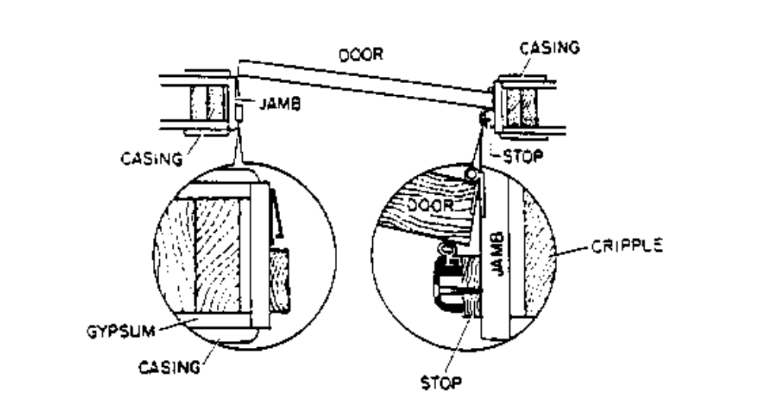

SECTION 3
WEATHERSTRIPPING STANDARDS

ITEM | MATERIALS | CRITERIA/REQUIREMENTS
9. Installation | Rigid gasket | - Must be attached with screws/nails placed a maximum of 9” apart and within 2” of each end
 | Spring and cushion | - Must be installed with screws/nails placed every 4” and placed with 2” of each end
 | Vinyl V-seal, replacement pile or Q-Lon* | - Must form an effective seal

* For replacement of original weatherstrip only
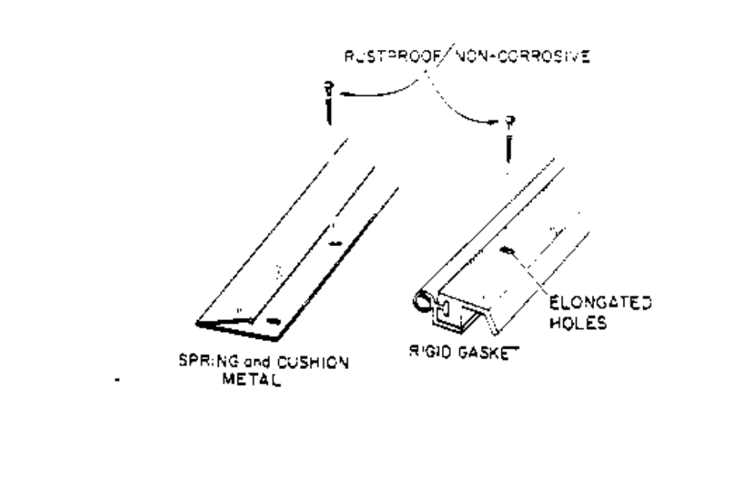

SECTION 3
WEATHERSTRIPPING STANDARDS

ITEM | MATERIALS | CRITERIA/REQUIREMENTS
10. Gasket to Gasket Contact | All types | - Gasket to gasket contact required at all corners (caulk may not be used to achieve this contact)
 |  | - Each section is not to have one continuous strip if possible
 |  | - Corner “V” notching of bulb-type materials, acceptable
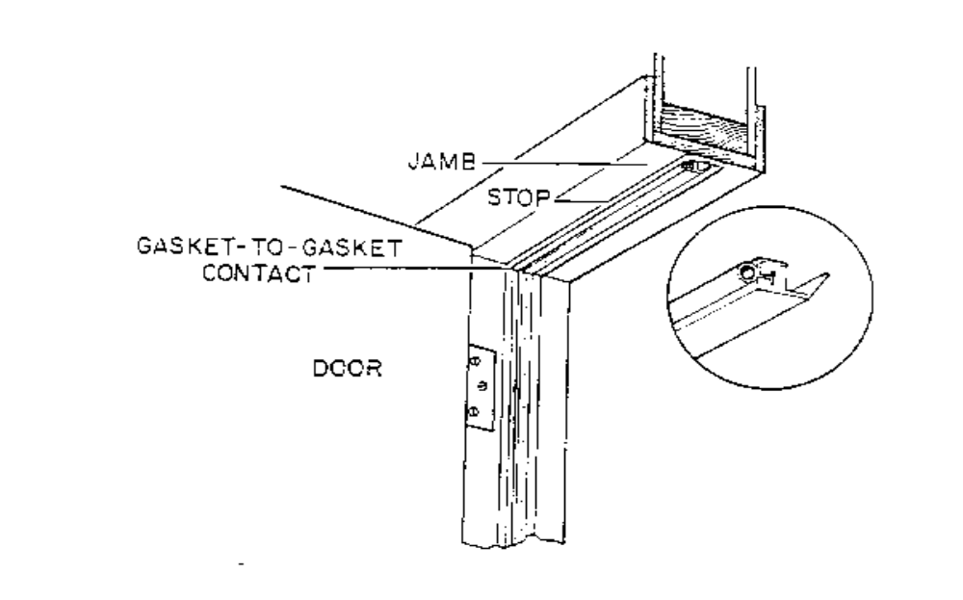
SECTION 3
WEATHERSTRIPPING STANDARDS

ITEM | MATERIALS | CRITERIA/REQUIREMENTS
11. Thresholds | Wood and metal | - Use only hardwood, treated wood or metal
 |  | - Gasket saddles are not recommended but may be used where appropriate
 |  | - Metal must be permanently screwed in place
 |  | - Wood must be nailed or screwed in place
 |  | - Perimeter of threshold must be caulked
 |  | - Screws coated or plated for exterior use should be used. Black/sheetrock screws are not allowed for attachment of thresholds

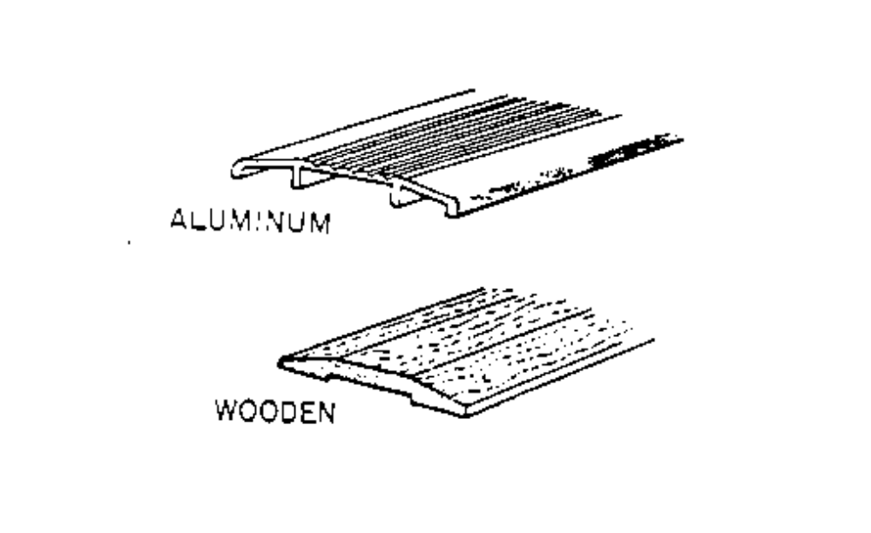

SECTION 3
WEATHERSTRIPPING STANDARDS

ITEM | MATERIALS | CRITERIA/REQUIREMENTS
12. Door Bottom | All types | - Must use door shoe/bottom or sweep with saddle threshold
 |  | - Shoe/bottom must have vinyl or silicone gasket and elongated mounting holes
 |  | - Door shoe/bottom may be L or U shaped and may include rain drip
 |  | - Retractable door sweep may be used when applicable

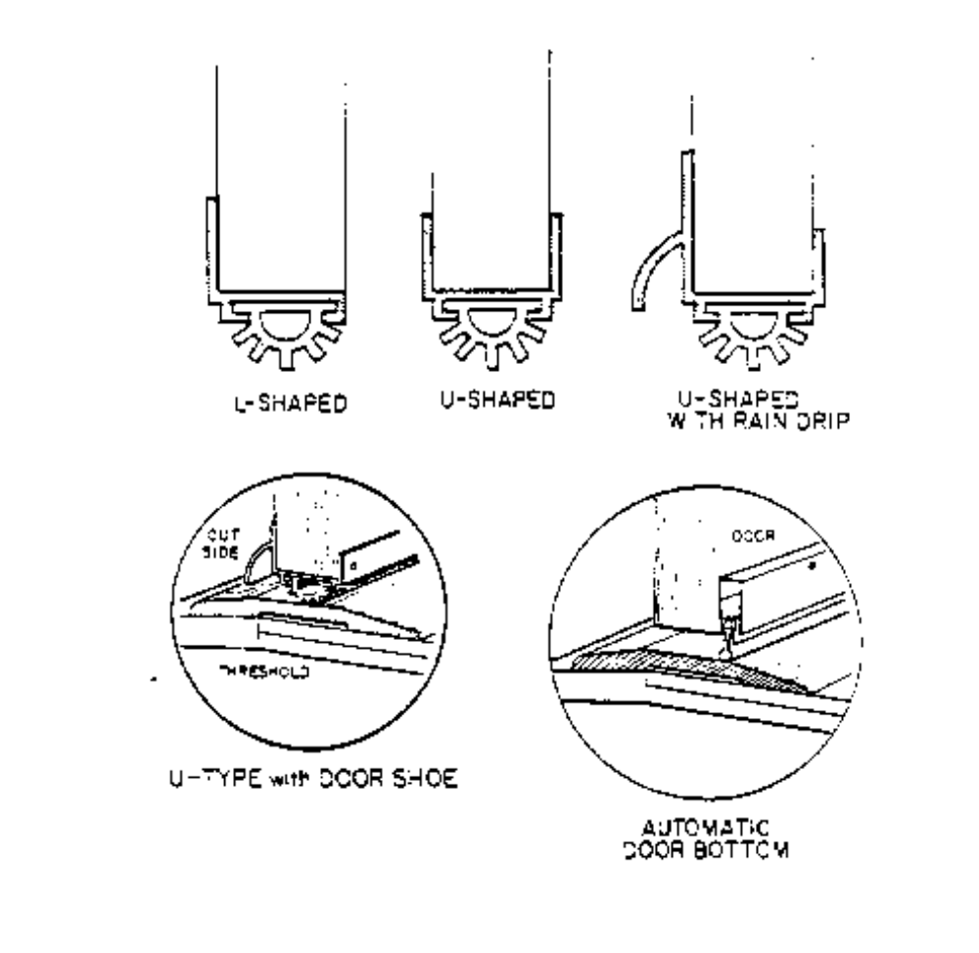
SECTION 3
WEATHERSTRIPPING STANDARDS

Nonfeasible Criteria for
Weatherstripping Windows

Do Not Install:

1. When already properly installed

2. When windows are located between two conditioned or two unconditioned areas

3. When windows are painted shut

4. When storm windows are present

5. When existing windows form an effective seal as installed

6. When not justified by a blower door test and an SIR ranking of 1.0 or better by the EASY Audit

Nonfeasible Criteria for
Weatherstripping Doors

Do Not Install:

1. When already properly installed

2. When doors are located between two conditioned spaces or two unconditioned areas

3. When not justified by a blower door test and an SIR ranking of 1.0 or better by the EASY Audit

SECTION 4
DOOR REPLACEMENT STANDARDS

ITEM |  | MATERIALS |  | CRITERIA/REQUIREMENTS
1. Replacement Doors |  | Wood |  | - Conforms to ANSI/NWWDA I.S. 1-87 or I.S. 6-86
 |  | Metal |  | - Conforms to ANSI/SDI 100-1985
 |  |  |  | - Must have minimum 20 minute fire rating
2. Dimension |  | Wood and Metal |  | - Match existing thickness, where applicable
 |  |  |  | - Use 1-3/4” thick door where feasible
3. Door Composition |  | Veneer/Metal |  | - Veneer must be a minimum of 1/8” thick
 |  |  |  | - Hardboard acceptable
 |  |  |  | - Exterior grade glue only
 |  |  |  | - Solid core wood or foam filled metal doors required for exterior use
- 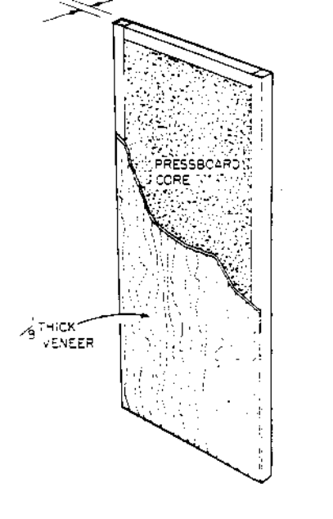  1/8” thick  veneer |  |  |  | - Foam filled wood doors are not acceptable for exterior use

SECTION 4
DOOR REPLACEMENT STANDARDS

ITEM | MATERIALS | CRITERIA/REQUIREMENTS
4. Door Finish | Wood | - Minimum of two coats of approved sealant is required for sealing doors
 |  | - Must be sealed on both sides and all four edges
 |  | - Acceptable sealers are:
 |  | --paint
 |  | --urethane
 |  | --varnish with stain
 |  | - If client elects to seal door, documentation must be in client file folder
 | Metal | - Must be painted or primed
 |  | - Oil based or epoxy paint only
5. Hinge Types | All doors | - Conforms to ANSI 633
 |  | - Minimum 3-1/2” x 3-1/2”
 |  | - Loose pin unless mounted toward exterior
 |  | - Brass or stainless steel
 |  | - Minimum of 3 per solid core door
 |  | - Square or rounded edge acceptable

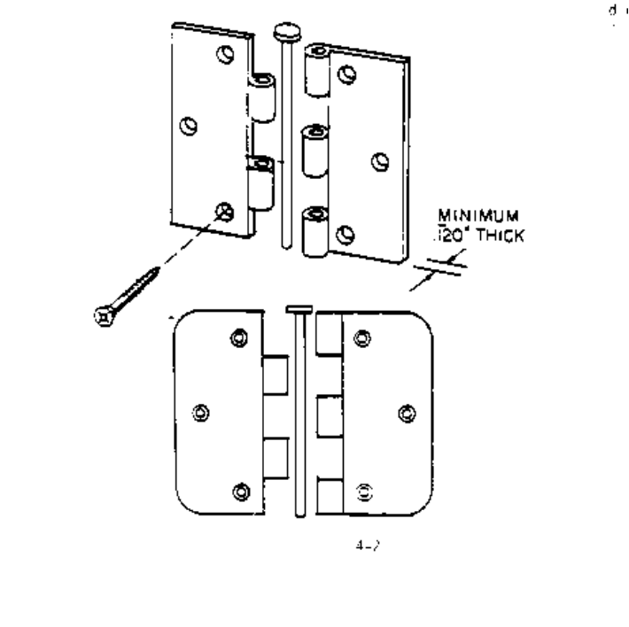
SECTION 4
DOOR REPLACEMENT STANDARDS

ITEM | MATERIALS | CRITERIA/REQUIREMENTS
6. Screws for Hinges | Wood jamb | - Flat head only
 |  | - Brass, stainless steel or plated screws allowed
 |  | - Minimum 5/8” penetration
 | Metal jamb | - Flat head machine screw required
7. Hinge Location | Wood and metal doors | - Three hinges required for solid core door
 |  | - Recommend lower hinge located 7” from upper jamb
 |  | - Recommend centering middle hinge between upper and lower hinges
 |  | - If jamb is not replaced, existing hinge location is acceptable, if adequate
8. Lockset Location | Entrance lock | - Match existing height if only door is replaced
 |  | - Recommend placing lock 36” from floor, if both door and jamb are replaced
 |  | - Recommend installing single cylinder dead bolt in addition to entrance lock
 |  | - All installed locks are to be keyed alike, if feasible
- 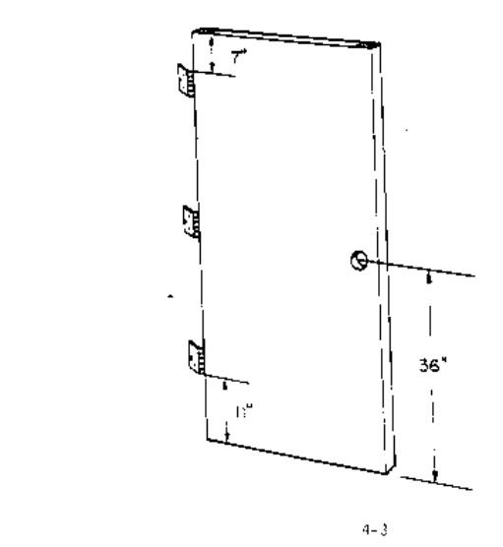 |  | - Existing dead bolt lock (or other locking mechanism) must be re-installed or replaced on all new door installations

SECTION 4
DOOR REPLACEMENT STANDARDS

ITEM | MATERIALS | CRITERIA/REQUIREMENTS
9. Alignment | Striker plate and latchbolt | - Striker plate to be installed so that door weatherstripping seals effectively
 |  | - Striker plate must easily accept piston (locking mechanism) without undue force or pressure
 |  | - 1/8” maximum distance from door to door stop when latch bolt and striker plate are engaged
10. Door Stop | Wood | - Paint grade acceptable unless existing jamb is natural finish
 |  | - Wood only unless metal jamb
 |  | - Maintain a minimum of 1” clearance between stop/jamb to door knob

SECTION 4
DOOR REPLACEMENT STANDARDS

ITEM | MATERIALS | CRITERIA/REQUIREMENTS
11. Door Casing | Wood | - Paint grade acceptable unless existing jamb is natural finish
 |  | - Match existing casing where possible
 |  | - Match existing miters
 | Nails/screws | - Use finishing or casing nails/screws for interior casing
 |  | - Use coated or plated nails/screws for exterior casings

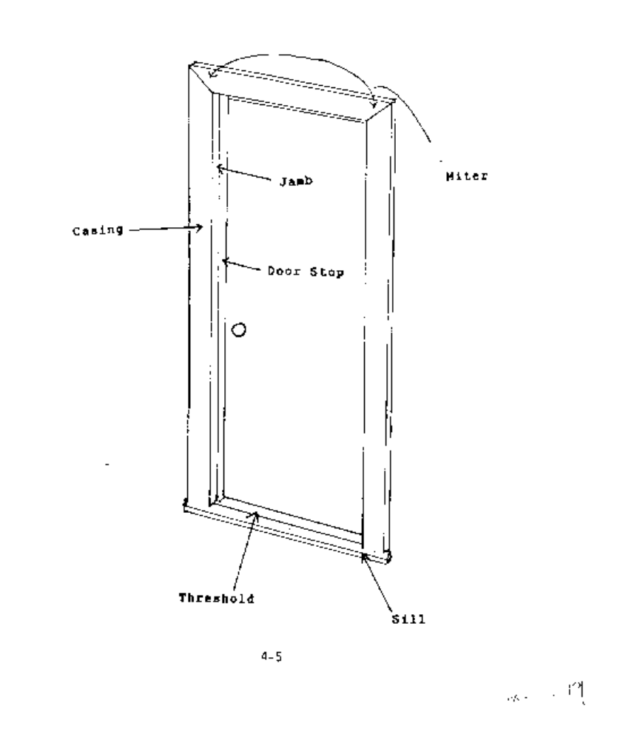
SECTION 4
DOOR REPLACEMENT STANDARDS

ITEM | MATERIALS | CRITERIA/REQUIREMENTS
12. Door Jamb | Replacement | - Minimum 3/4” thick
 |  | - Use exterior type if entire jamb is replaced
 |  | - Miter all corners of jambs were possible
13. Door Modification | Wood | - If core is exposed by trimming, the stile must be replaced or core edge effectively sealed against the weather
 |  | - A maximum of 1” may be cut from either door side
 |  | - Recommend a 5º bevel be cut on lockset edge
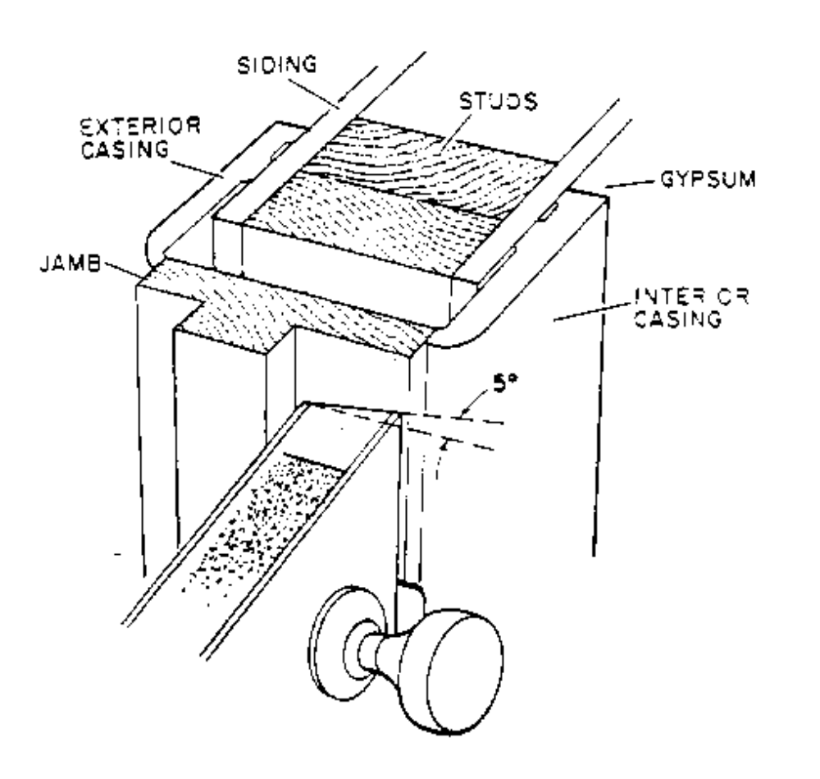
SECTION 4
DOOR REPLACEMENT STANDARDS

ITEM | MATERIALS | CRITERIA/REQUIREMENTS
14. Warpage | Door | - At installation, door must not have warpage measured at the deepest point greater than 1/4” from top to bottom (end to end)
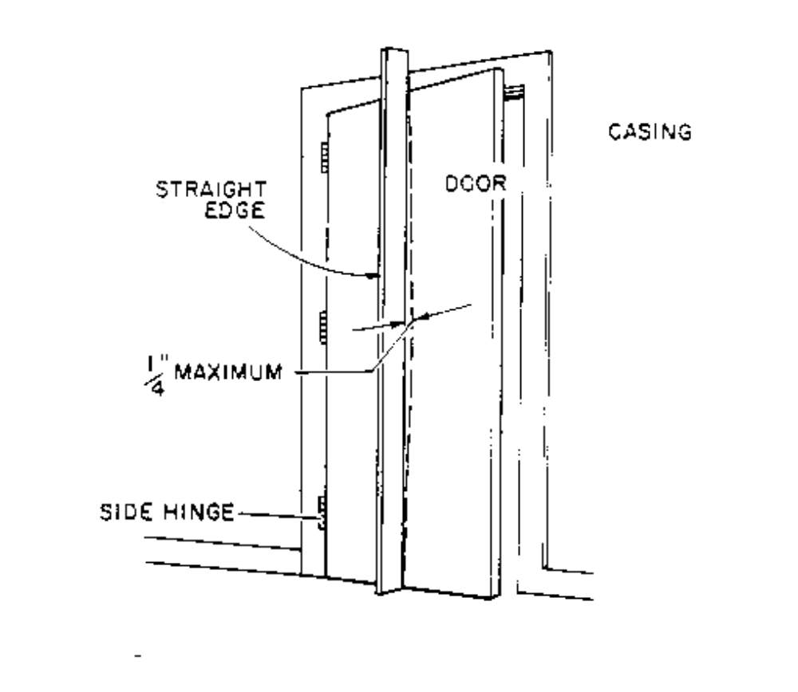
SECTION 4
DOOR REPLACEMENT STANDARDS

ITEM | MATERIALS | CRITERIA/REQUIREMENTS
15. Door Glass | Exterior doors | - Not allowed for replacement doors
 |  | Recommend installing a 180º peepsite at clients eye level
16. Patio Door | Sliding glass/aluminum | - Patio doors that are broken or do not seal must be addressed
 |  | - Recommend replacing with door/window combination or solid wall if a secondary entrance meeting egress requirements is present

Nonfeasible Criteria For
Door Replacement

Do Not Install:

1. When repair of the existing door may be effectively accomplished without replacement

2. When client refuses replacement (must be documented in client file folder)

3. When not justified by an SIR ranking of 1.0 or better by the EASY Audit

SECTION 5
WINDOW AND GLASS REPLACEMENT STANDARDS

ITEM | MATERIALS | CRITERIA/REQUIREMENTS
1. Acceptable Replacement Windows | Aluminum slider | - Replace with aluminum slider
 |  | - Must conform to ANSI/AAMA 101-88 (documentation required)

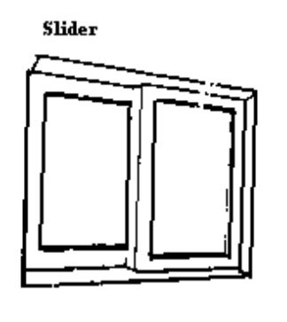

 | Double Hung | - Replace with double hung or single hung window
 |  | - Aluminum replacement must conform to ANSI/AAMA 101-88 (documentation required)
 |  | - Wood replacement must conform to ANSI/NWWDA I.S. 2-87 (documentation required)
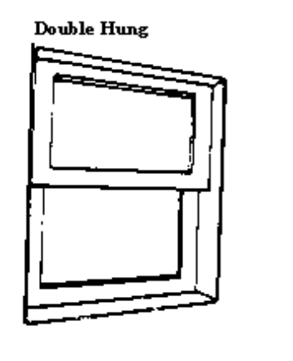

SECTION 5
WINDOW AND GLASS REPLACEMENT

ITEM | MATERIALS | CRITERIA/REQUIREMENTS
1. Acceptable Replacement Windows (continued) | Jalousie/metal casement | - Replace with double hung, single hung or slider as appropriate
 |  | - If replacement is not feasible (or client refuses), interior storm windows may be installed. Use of this treatment must be well documented in client file folder. Any other treatment of jalousie or metal casement windows must be justified and documented in client file folder
 |  | - All replacement windows must conform to applicable DOE standards with documentation available for review
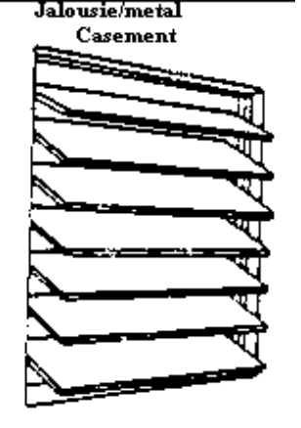
SECTION 5
WINDOW AND GLASS REPLACEMENT STANDARDS

ITEM | MATERIALS | CRITERIA/REQUIREMENTS
2. Sash | Wood | - Decayed or deteriorated sashes must be replaced
 |  | - Top sash of double hung unit must be pushed up, blocked and caulked shut. Obtain client’s approval for this treatment
3. Structural Integrity | Rough window frame | - Structural framing must be repaired or replaced as needed before installing replacement window
 |  | - Framing members must be free of dry rot or pest damage
4. Jambs | All types of replacement windows | - It is strongly recommended that replacement windows be sized to fit existing jamb openings (i.e. “custom” windows should be used for non-standard installation). Prime (new construction) windows which fit existing opening may be used only if custom replacement windows are not available. Installation of new construction windows shall be in a manner to effectively prevent air infiltration and water penetration and shall be neat in appearance
 |  | - Any damaged window stop must be replaced
SECTION 5
WINDOW AND GLASS REPLACEMENT STANDARDS

ITEM | MATERIALS | CRITERIA/REQUIREMENTS
5. Sills | All openings | - Must be replaced when dry rot or deterioration is present
 |  | - Must be sealed with a minimum of 2 coats of approved sealant (see section 4-4, third bullet)
 |  | - Must be installed with a 5 degree slant toward ground
6. Cavities | Insulation | - Opening between rough framing and window jamb (cavity) shall be insulated when cavity is exposed prior to or during weatherization work. If window weights (pulleys) are operational, do not block with insulation

7. Casing | Wood | - Paint grade acceptable unless existing jamb is natural finish
 |  | - Match existing casing where possible
 |  | - Match existing miters
 | Nails/screws | - Use finishing or casing nails/screws for interior casings
 |  | - Use coated or plated nails/screws for exterior casings

SECTION 5
WINDOW AND GLASS REPLACEMENT STANDARDS

Window Replacement
Outside View of Old Window. This is a typical window. Your window may differ slightly.
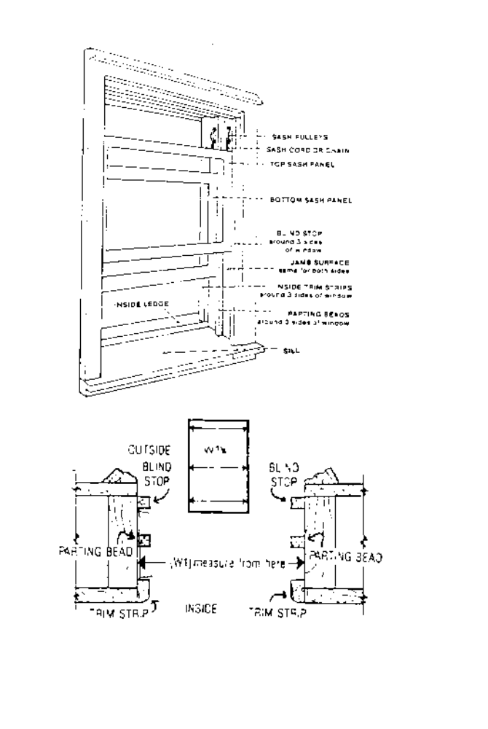
SECTION 5
WINDOW AND GLASS REPLACEMENT STANDARDS

Window Replacement
Note: Check Measurements of New Windows for Correct Sizes Before Installation.

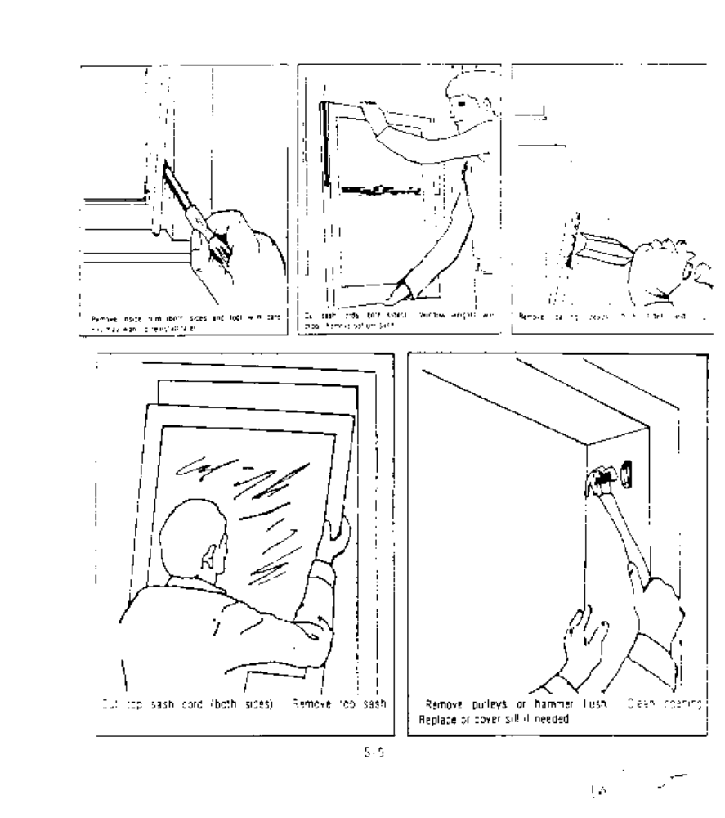

SECTION 5
WINDOW AND GLASS REPLACEMENTSTANDARDS

Window Replacement

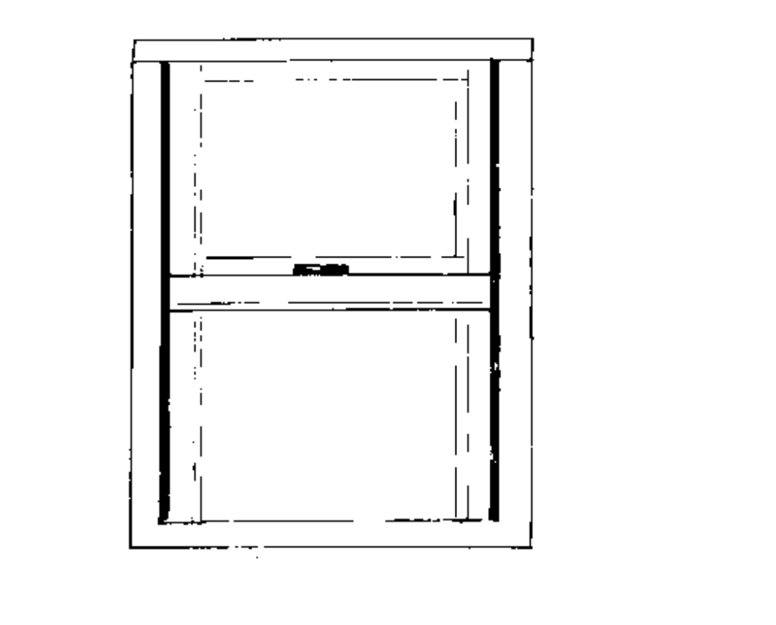
Sash gap should be the same at the mid section of the window as it is at the top and bottom

- In extreme cases the old window opening might be badly “bowed”. If the adjustments do not solve this problem, wood shims will have to be used between the rough opening and the replacement window jambs

SECTION 5
WINDOW AND GLASS REPLACEMENT STANDARDS

Window Replacement

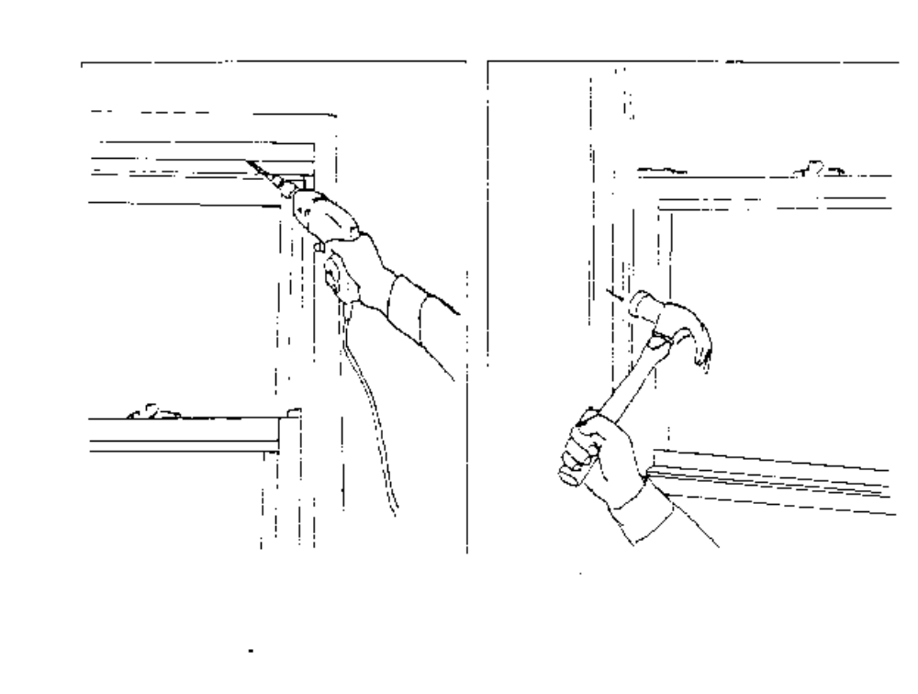
Adjust top expander all the way up if necessary. Caulk around the entire perimeter of the window on the outside, then inside. Replace the old trim strips or install new trim at the head and jambs

SECTION 5
WINDOW AND GLASS REPLACEMENT STANDARDS

ITEM | MATERIALS | CRITERIA/REQUIREMENTS
8. Cavities | Insulation | - Exposed openings between rough opening and jamb must be insulated

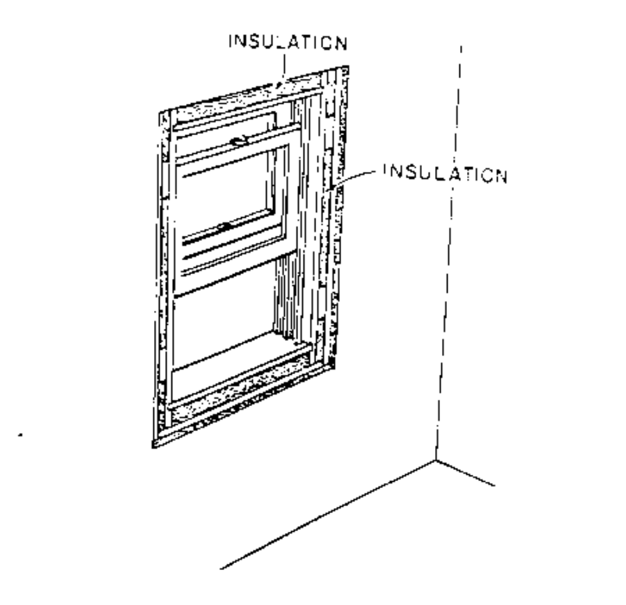

SECTION 5
WINDOW AND GLASS REPLACEMENT STANDARDS

Nonfeasible Criteria for
Window Replacement

Do Not Install:

1. When existing window may be repaired to effectively prevent air infiltration and moisture penetration; AND

2. When not justified by an SIR ranking of 1.0 or better by the EASY Audit

SECTION 5
WINDOW AND GLASS REPLACEMENT STANDARDS

Glass Replacement

ITEM | MATERIALS | CRITERIA/REQUIREMENTS
9. Allowable Materials | Single strength glass (SS) | - Allowed for openings up to 100 U.I.*
 | Double strength glass (DS) | - Required for opening greater than 100 U.I.* but not greater than 150 U.I.*
 | Plate glass | - Recommend that openings greater than 150 U.I.* be converted to accept two or more standard replacement window units
 | Safety glass | - As required by local code
 |  | - May use rigid plastic sheets in lieu of safety glass
 | Plastic sheets | - Must be UV treated
 |  | - Must be at least 1/8” thick
 |  | - Polycarbonate recommended
 | Plastic film | - Not allowed

*U.I. = United inches = One width measurement in inches plus one length measurement in inches.

Example: 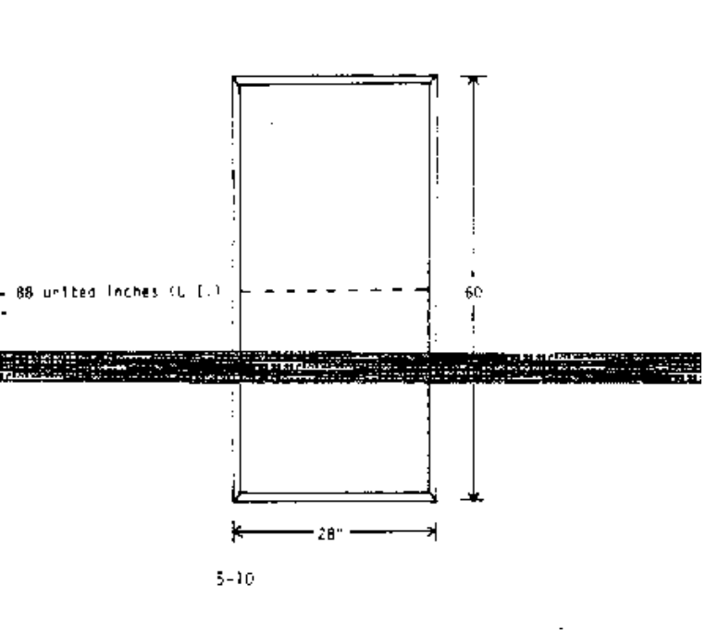
28” + 60” = 88 united inches
60”
28”
SECTION 5
WINDOW AND GLASS REPLACEMENT STANDARDS

Glass Replacement

ITEM | MATERIALS | CRITERIA/REQUIREMENTS
10. Glazing Compounds | Wood sash | - Caulking tube-type glazing recommended (commercially available)
 | Metal sash | - Caulking tube-type glazing not recommended
 |  | - Match existing glazing beads (or strips) where feasible
 | Wood and metal | - Glazing materials must remain pliable

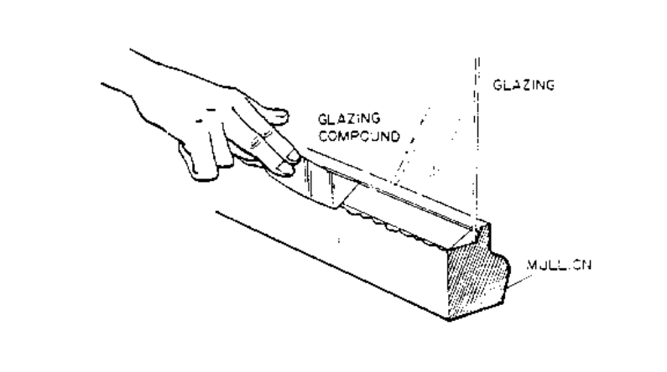

11. Treatment of Sash | Wood sash | - Must be clean and free of dirt or loose material
 |  | - Decayed or deteriorated sash must be replaced
 |  | - Follow manufacturer’s requirements for treating surface
 | Metal sash | - Must be clean and treated with rust inhibitor
SECTION 5
WINDOW AND GLASS REPLACEMENT STANDARDS

Glass Replacement

ITEM | MATERIALS | CRITERIA/REQUIREMENTS
12. Push Points | Wood Sash | - Must be installed
 |  | - Points spaced a maximum of 8” apart
 |  | - Points located within 4” of each corner
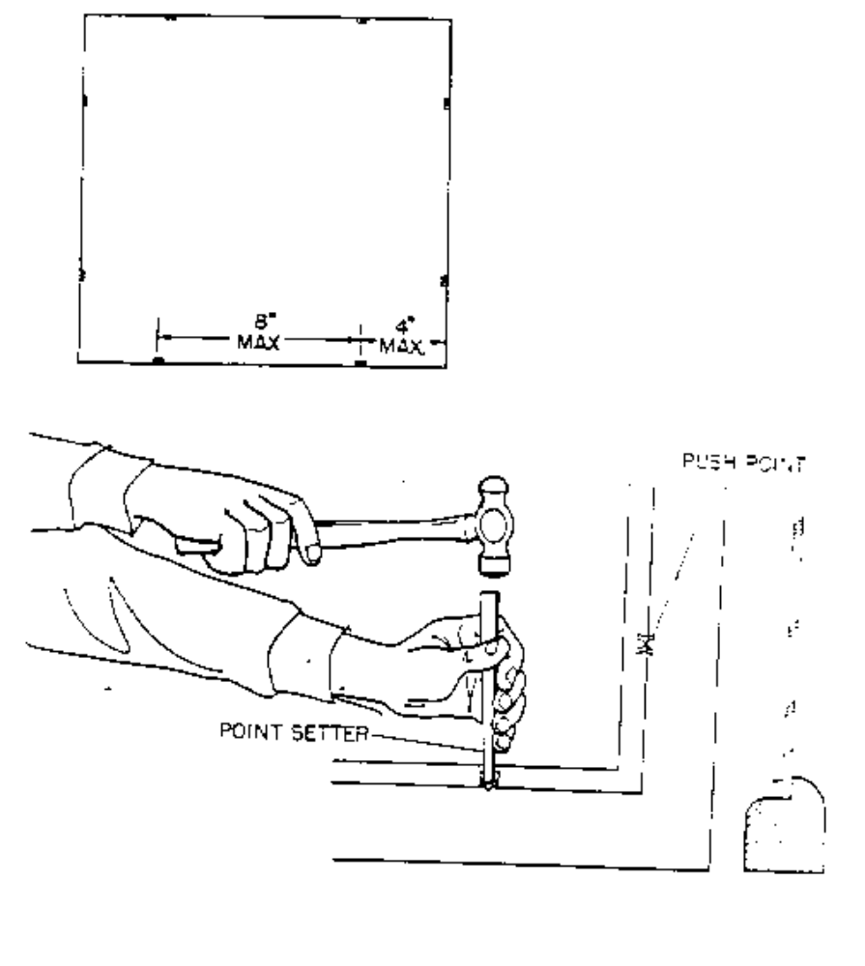
SECTION 5
WINDOW AND GLASS REPLACEMENT STANDARDS

Glass Replacement

ITEM | MATERIALS | CRITERIA/REQUIREMENTS
13. Spring Clips | Steel casement | - Recommend installation of spring clips
 |  | - Spaced a maximum of 12” apart
 |  | - Clips located within 4” of each corner

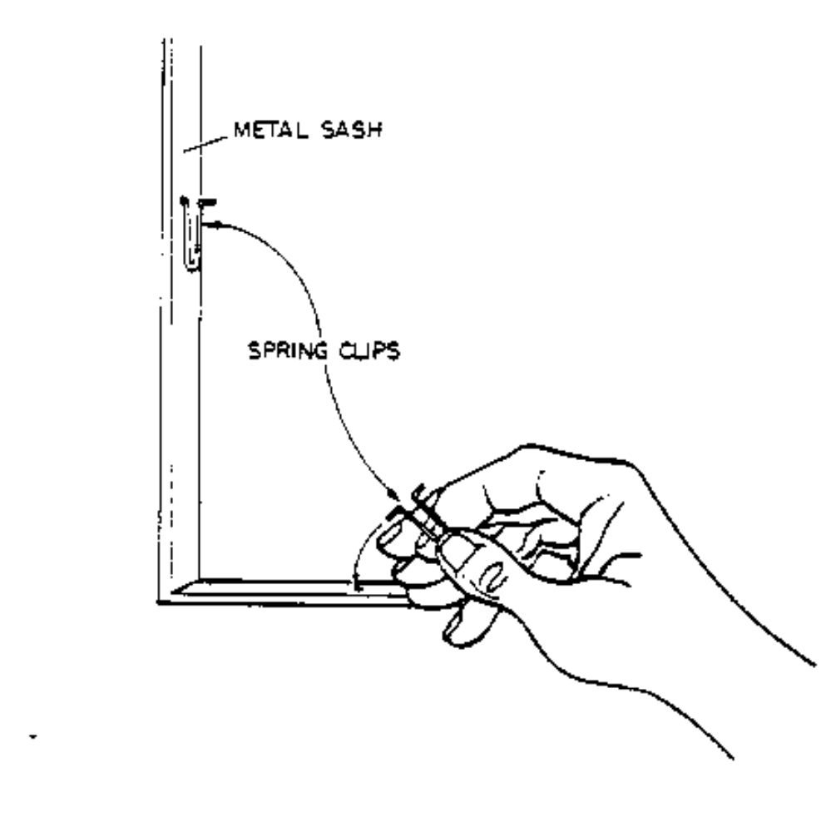
SECTION 5
WINDOW AND GLASS REPLACEMENT STANDARDS

Glass Replacement

ITEM | MATERIALS | CRITERIA/REQUIREMENTS
14. Safety Glass in Doors |  | - Required for replacement of existing broken safety glass in doors, windows and patio doors
15. Cushion Bead | Wood and metal | - Required on all glass installations
 |  | - Bead must be continuous and free of voids
 |  | - Use appropriate material (i.e. glazing compound in wood sash windows; caulking compound recommended for metal sashes)

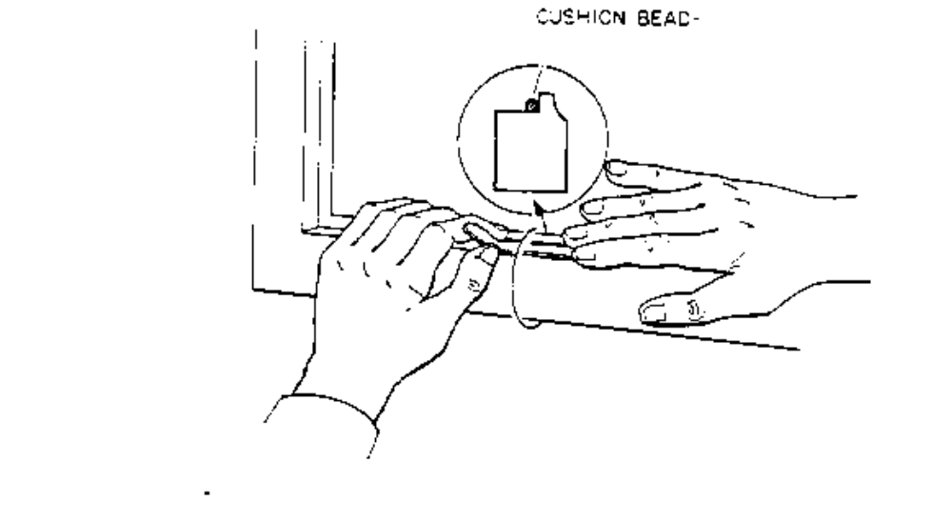
16. Finish Bead | Wood | - Finish bead must not be visible from reverse side
 | Metal | - Match existing glazing bead or strips, where possible
 |  | - Caulking type glazing compound not recommended

SECTION 5
WINDOW AND GLASS REPLACEMENT STANDARDS

Glass Replacement

Nonfeasible Criteria for
Glass Replacement

Do Not Install:

1. When small hole, 1/4” or less, is present and can be patched with clear silicone

2. When crack is less than 6” long, and it cannot go any further

3. When not justified by an SIR ranking of 1.0 or better by the EASY Audit

SECTION 6
PIPE AND WATER HEATER INSULATION STANDARDS

Pipe Insulation

ITEM | MATERIALS | CRITERIA/REQUIREMENTS
1. Acceptable Materials | All types | - Minimum life expectancy of 10 years
 |  | - Must be capable of continuous operation at 180º F
 |  | - Must have a flame spread rating of 150 or less and a smoke density of 50 or less
 |  | - Construction of mineral fiber elastomer, urethane, isocyanurate or other suitable material is acceptable. Urethane is most common
 |  | - Minimum thickness of 3/4”
 |  | - Heat tape or strap insulation not allowed
 |  | - Must be pre formed to fit standard pipe diameters
 |  | - Insulate both inlet and outlet water heater pipes under continuous water pressure
2. Pipes to be insulated | Hot and cold water pipes | - Where feasible, insulate pipes in both conditioned and unconditioned spaces
 |  | - Do not insulate leaking pipes
 |  | - Do not insulate gas pipes
 |  | - Do not insulate when water is not working

3. Coverage | Allowable materials | - Insulate hot and cold water pipes
 |  | - In conditioned space, insulate first 5’ leading away from tank (if no obstruction exists)
 |  | - In unconditioned space, insulate all accessible pipes leading to conditioned space
 |  | - On gas units, water pipes must be insulated to within 3” of exhaust vent
 |  | - Cover all elbows or curved pipe without compressing insulation or leaving gaps
 |  | - Elbows should be 45º mitered to form fit all pre formed insulation

SECTION 6
PIPE AND WATER HEATER INSULATION STANDARDS

Pipe Insulation

TAPE FOR ATTACHMENT
Maximum flame spread rating of 25

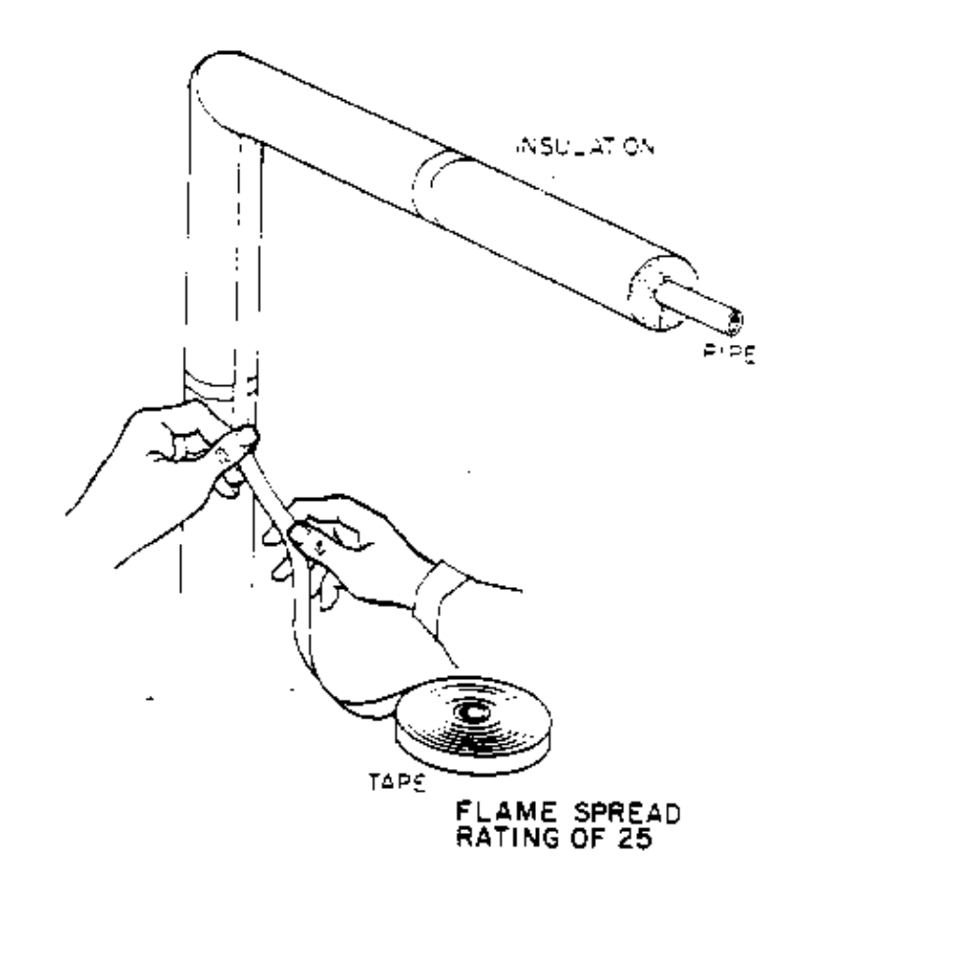
SECTION 6
PIPE AND WATER HEATER INSULATION STANDARDS

Pipe Insulation

ITEM | MATERIALS | CRITERIA/REQUIREMENTS
4. Coverage Requirements | Insulation | - Insulate hot and cold water pipes
 |  | - Insulate first 5’ leading away from tank or as far as possible when obstructions prevent a full 5 feet
 |  | - Cover all elbows and curved pipe, without compression or gaps
 |  | - Miter elbows to form fit all pre- formed insulation

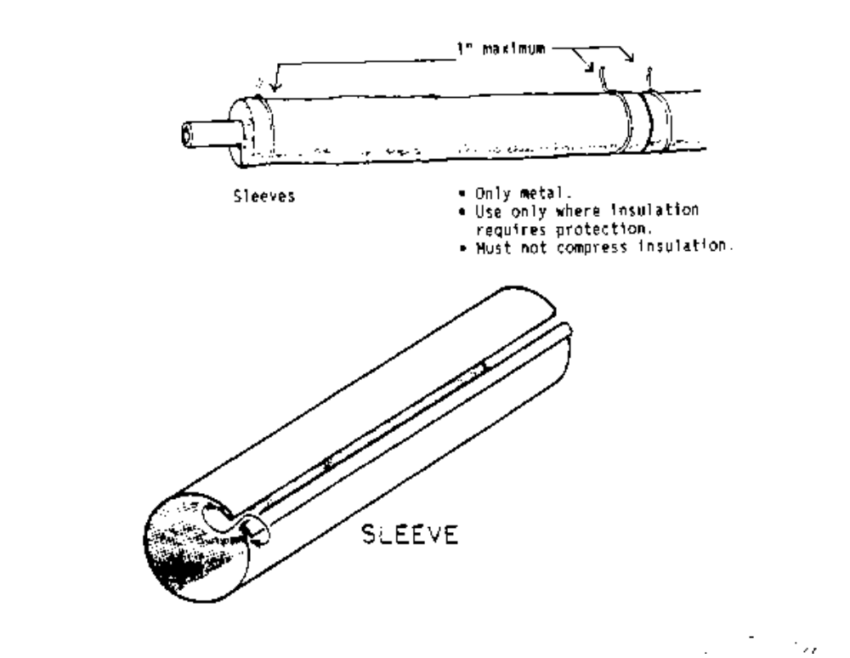
SECTION 6
PIPE AND WATER HEATER INSULATION STANDARDS

Pipe Insulation

ITEM | MATERIALS | CRITERIA/REQUIREMENTS
5. Installation | All materials | - Insulation must be firmly secured (but not compressed) using tape, plastic ties or metal sleeves
 | Tape | - Must have flame spread rating of 25 or less
 |  | - Duct tape is not allowed
 | Ties | - Must be installed so as not to slip and not to compress insulation
 |  | - Place 1” from the ends and at all joints; other ties should be spaced closely enough to secure the insulation
 | Sleeves | - Only metal
 |  | - Use only where insulation requires protection
 |  | - Must not compress insulation

 | Slits | - On vertical pipes, slits may be taped and joints (where two sections of insulation meet) may be taped or strapped
 |  | - On horizontal pipes, slits must face down and must not be taped (to allow condensation to discharge)

SECTION 6
PIPE AND WATER HEATER INSULATION STANDARDS

Pipe Insulation

ITEM | MATERIALS | CRITERIA/REQUIREMENTS

Position of Slits

Position slit downward on horizontal pipe.

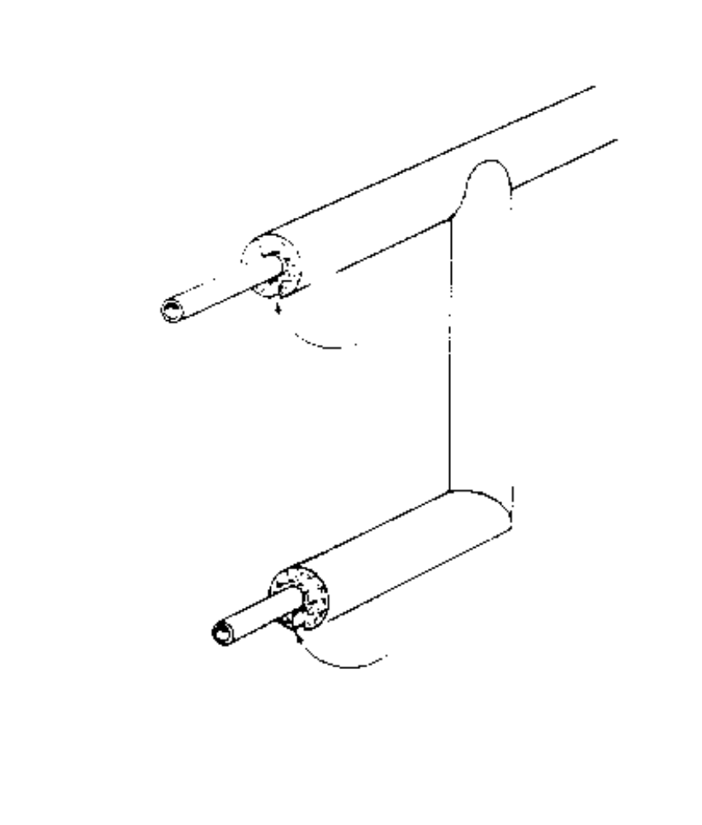

Do Not Cover:
- pressure/temperature (p/t) relief valves
- valve handles
- control and safety devices
- P/T drain lines

SECTION 6
PIPE AND WATER HEATER INSULATION STANDARDS

Water Heater Insulation

ITEM | MATERIALS | CRITERIA/REQUIREMENTS
6. Allowable Materials | Blankets | - Conforms to ASTM C592-80
 | High temperature blankets | - Conforms to ASTM 892-89
 | Fiber blankets | - Must be mineral fiber only
 | All blankets | - Minimum R-6.9
 |  | - Maximum 25 flame spread rating
 | Tape | - Duct tape not allowed
 |  | - Maximum 25 flame spread rating
 |  | - Tape only not acceptable, must also use straps or retainers
7. Items to check prior to installing insulation | All water heaters | - Water heater is in working order  - Water heater is not leaking
 |  | - Water heater is not already insulated (Note: if a label with ASHRAE standards 90-75 or 90-80 or, if R-12 or greater is attached, it is not to be insulated)
 |  | - Is a minimum of 3” clearance on sides and back and 6” on front present? If not, do not insulate
 |  | - Is water heater protected from the weather? If not, you may build a protective enclosure (this is repair material). Do not insulate units which remain unprotected

SECTION 6
PIPE AND WATER HEATER INSULATION STANDARDS

Water Heater Insulation

ITEM | MATERIALS | CRITERIA/REQUIREMENTS
8. Items to check prior to installing insulation (continued) | All water heaters  (continued) | - Does an operable pressure relief valve exist? If a pressure relief is plugged or does not exist, you must unplug the valve or install a relief valve before you insulate the water heater (Install by local or CABO codes). Note: This action is required only if the water heater is addressed. If you are not going to install a pressure relief valve, you must advise the client of the possible dangers of the situation and suggest they have it corrected
 |  | - If an operable relief valve exists with no drain line, you may install a drain line following local codes or CABO standards

 |  | Gas (or propane/butane) | - If no vent pipe exists or if the vent pipe is incorrectly installed, you must correct the problem if you are going to insulate the water heater. (Note: A 3” clearance between the vent pipe and the blanket or tape must be maintained) When installing a vent pipe, it must be double walled and vented to the outside atmosphere
 |  |  | - If there is no burner access door, appliance valve or inadequate combustion air, you must correct the problem before installing insulation

SECTION 6
PIPE AND WATER HEATER INSULATION STANDARDS

Water Heater Insulation

ITEM | MATERIALS | CRITERIA/REQUIREMENTS
9. Items to check prior to installing insulation (continued) | All water heaters  (continued) | - If there is incomplete combustion (as indicated by smoke or soot on the outside of the heater), you must correct the problem before installing insulation
 | Electric | - If hazardous wiring exists, you must correct the problem before insulating the unit

Water Heater Insulation

ASHRAE STANDARDS

This unit meets or exceeds minimum ASHRAE Standards 90-75 (or 90-80).
Do not install additional insulation on this unit

Water heaters bearing this tag or a similar tag, shall not receive additional insulation. If no tag is present, insulate

SECTION 6
PIPE AND WATER HEATER INSULATION STANDARDS

Water Heater Insulation

ITEM | MATERIALS | CRITERIA/REQUIREMENTS
10. Location of Water Heater | N/A | - Must be in protected area (not exposed to weather)
 |  | - Must have minimum 3” clearance on sides and back, and 6” from front
 |  | - Insulate even, if located in conditioned area

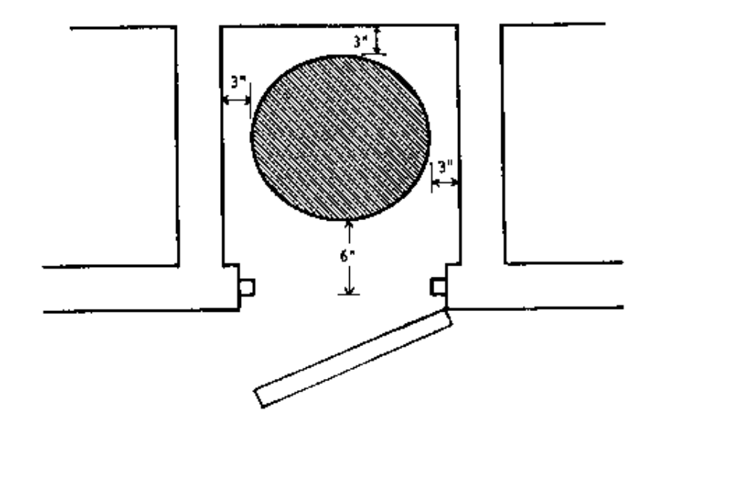

SECTION 6
PIPE AND WATER HEATER INSULATION STANDARDS

Water Heater Insulation

ITEM | MATERIALS | CRITERIA/REQUIREMENTS
11. Water Heater Insulation Installation Requirements | All blankets  (For Water Heater) | - Must install 3 retainers (straps, not tape) as follows:  --one retainer within 3” of the top  --one retainer in the middle  --one retainer as close to the bottom as is feasible without covering the panels
 |  | - The top (if gas) and side seams must be sealed with tape
 |  | - All retainers must be installed so as to prevent blanket from slipping, but not so tight as to compress the insulation
 |  | - Safety instructions must not be covered. Before installing the blanket, mark the blanket where the safety instructions will be located. After the blanket is properly installed, cut around the safety instructions and then tape the loose insulation edges to the water heater
 |  | Do Not Cover:
 | All blankets | - drain valves (retain 1” clearance)  - end of drain line from pressure relief valve  - access plates except for electric heaters as illustrated on pages 6-12  - safety instructions
SECTION 6
PIPE AND WATER HEATER INSULATION STANDARDS

Water Heater Insulation

ITEM | MATERIALS | CRITERIA/REQUIREMENTS
11. Water Heater Insulation Installation Requirements (continued) | Gas Units  (Water Heaters) | Do Not Cover:  - Do not cover access doors, vents, thermostat and controls  - Blanket must be at least 3” from access doors and vents  - Do not insulate top of water heater  - Do not cover appliance valve
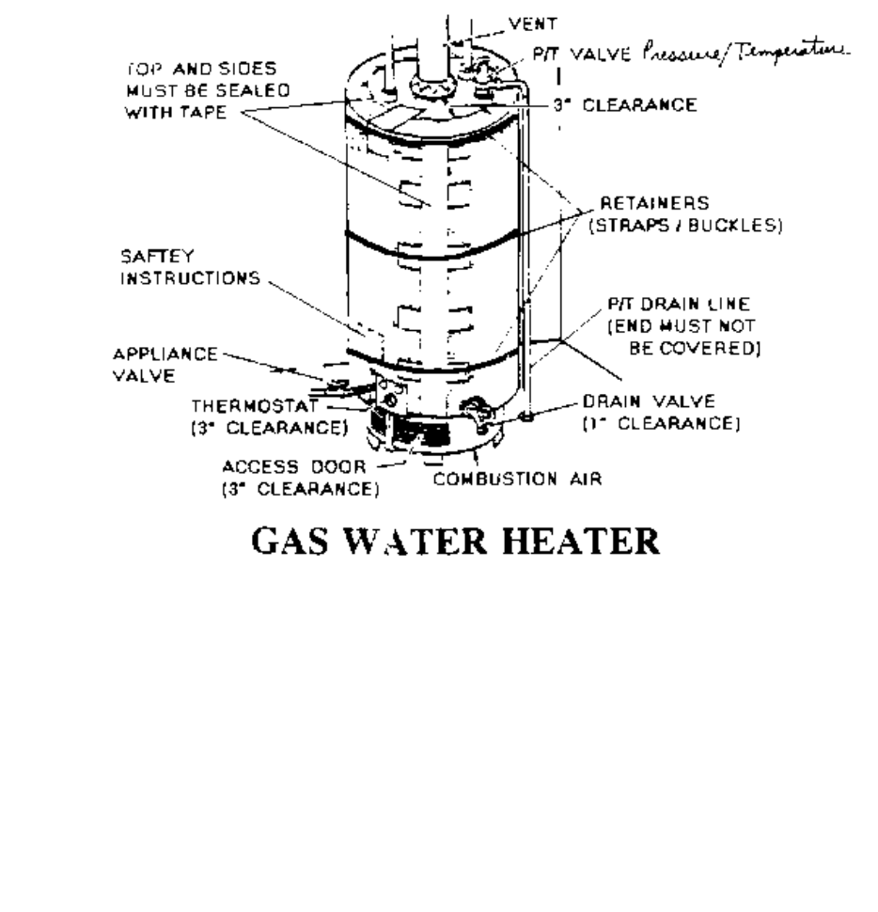
- Locate one retainer a maximum of 3” from top, one retainer in the middle, and one retainer as close to the bottom of the tank as feasible
- Top and bottom retainer should be well secured to prevent the blanket from shifting. The middle retainer should be secured to prevent the blanket from coming apart, but not over-tightened compressing the insulation
- Do Not over tighten the middle strap or the R-value of the blanket will be lost

SECTION 6
PIPE AND WATER HEATER INSULATION STANDARDS

Water Heater Insulation

ITEM | MATERIALS | CRITERIA/REQUIREMENTS
11. Water Heater Insulation Installation Requirements (continued) | Electric Units  (Water Heaters) | - Do insulate the top of the water  heater
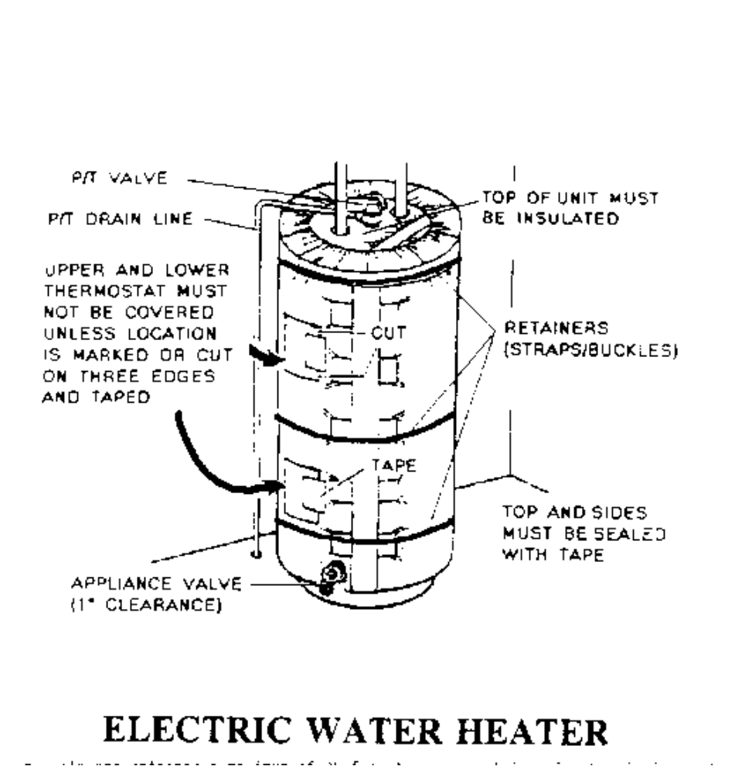

- Do Not cover the upper or lower thermostats
- Locate one retainer a maximum of 3” from top, one retainer in the middle, and one retainer as close to the bottom of the tank as feasible
- Top and bottom retainer should be well secured to prevent the blanket from shifting. The middle retainer should be secured to prevent the blanket from coming apart, but not over-tightened compressing the insulation
- Do Not over tighten the middle strap or the R-value of the blanket will be lost

SECTION 6
PIPE AND WATER HEATER INSULATION STANDARDS

Water Heater Insulation

ITEM | MATERIALS | CRITERIA/REQUIREMENTS
12. Gas Water Heater Ventilation | Gas Units  (Water Heaters) | - Gas water heaters located in conditioned spaces opening into a sleeping area must have outside combustion air. Local codes or CABO standards must be followed in meeting this requirement
 |  | - Units located inside a conditioned space with outside combustion air shall be treated as if located in an unconditioned space. The water heater closet door shall be weatherstripped. If no door is present, install a hollow core door and weatherstrip
13. Setting Water Heater Temperature | All Units (Gas & Electric) | - Do Not set the temperature  - Advise clients of energy savings from setting the thermostat to low or medium
 |  | - Recommend that the client set the thermostat to low or medium

SECTION 7
ATTIC/CEILING INSULATION AND VENTILATION STANDARDS

Attic/Ceiling Insulation

ITEM | MATERIALS | CRITERIA/REQUIREMENTS
1. Allowable Materials | Mineral Fiber  - Blankets  - Loose fill | - Conforms to ASTM  C665-88  - Conforms to ASTM  C764-88
 | Mineral Cellular  - Vermiculite (loose fill)  - Perlite (loose fill) | - Conforms to ASTM C516-80 (1885)  - Conforms to ASTM C549-81 (1986)
2. R-Values | All materials | - Attic floor: (ceilings) minimum R-30 (higher if required by local code)

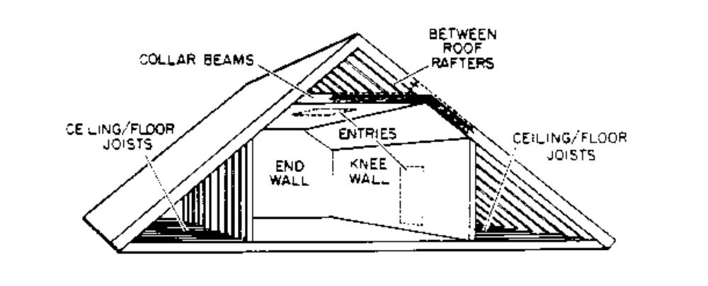
SECTION 7
ATTIC/CEILING INSULATION AND VENTILATION STANDARDS

Attic/Ceiling Insulation

ITEM | MATERIALS | CRITERIA/REQUIREMENTS
2. R-Values (continued) | All materials | - Knee walls: (if over 12” high) R19 preferred, R-11 minimum

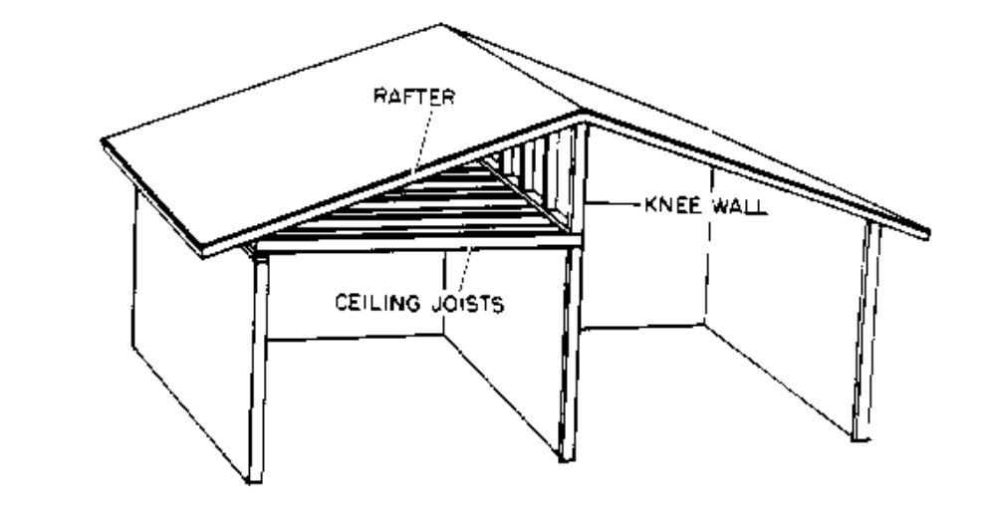
SECTION 7
ATTIC/CEILING INSULATION AND VENTILATION STANDARDS

Attic/Ceiling Insulation

ITEM | MATERIALS | CRITERIA/REQUIREMENTS
2. R-Values (continued) | All materials | - Attic Access: (hatch cover located in conditioned area only) R-19
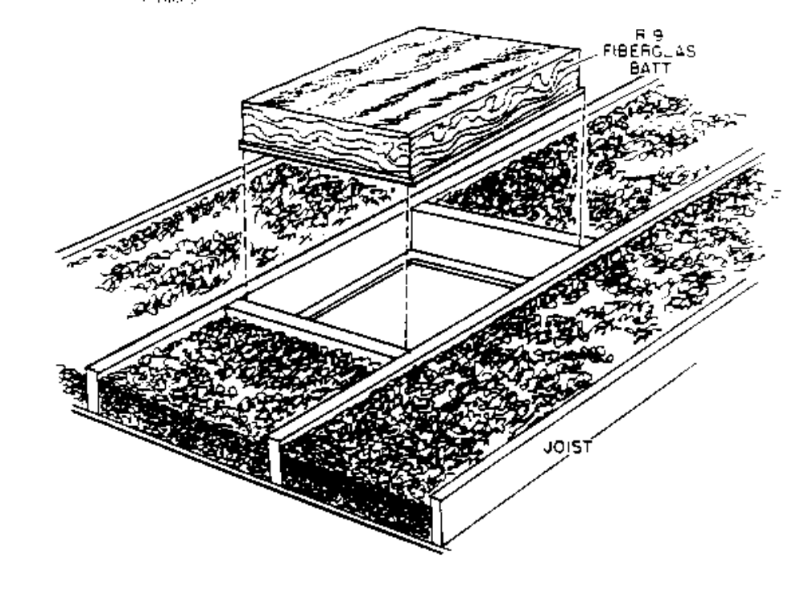

 | Loose fill | - Permanently affix a certification card to a ceiling rafter so that it is easily visible from the attic entry.  Certification Card is to state: the installed R-value, the number of bags installed, the date of installation and the installer’s name  - It is recommended that a depth (or density) table be affixed next to the certification card (can be cut from a discarded insulation bag)
SECTION 7
ATTIC/CEILING INSULATION AND VENTILATION STANDARDS

Attic/Ceiling Insulation

ITEM | MATERIALS | CRITERIA/REQUIREMENTS
3. Pre-Installation Procedures | Roof all materials | - Do Not install if roof leaks over conditioned spaces and cannot be repaired
 |  | - All roof repair or replacement must be completed before insulation is installed
 |  | - Broken or cracked rafters should be replaced or repaired with doublers which extend at least 2’ each side of break or crack
 |  | - Rafter braces are recommended, but braces must be attached at wall plates
 |  | - Roof “bowls” (concave areas) should be eliminated by bracing or overlaying
 | Ceiling all materials | - Do Not install if ceiling over conditioned spaces cannot be made to support the weight of the insulation
 |  | - Ceiling must be structurally capable of supporting insulation weight
 |  | - Room-side lath strips may be installed with client approval, to cover or support damaged or questionable joints
 |  | - Thin panels may be laid over attic side of joist to keep weight of insulation off good 1/2” sheetrock or 1/2” ceilings with excessive joist spacing
 |  | - Weak or damaged sheetrock under board ceilings does not have to be replaced or repaired unless board cracks or joints allow insulation to fall through
 |  | - Board ceilings with lap or tongue/groove joints or butt joints with spaces equal to or less than 1/16” do not need to be sealed if insulation is installed

SECTION 7
ATTIC/CEILING INSULATION AND VENTILATION STANDARDS

Attic/Ceiling Insulation

ITEM | MATERIALS | CRITERIA/REQUIREMENTS
3. Pre-Installation Procedures (continued) | Blocking all materials | - All required blocking should be completed (see part 7 this section)
 | Venting all material | - All required venting should be completed (see part 11 this section)
4. Where to Install | All materials | - Attic floor
 |  | - Must be installed level at equal depths
 |  | - Maintain a minimum of 1” (3” preferred) clearance from underside of roof at eve
 |  | - Vapor barrier if present, must be installed toward conditioned area
 | Bats or blankets | - Knee walls; hatch covers in conditioned areas
5. Where Not To Install | All materials | - When attic clearance is less than 24”
 |  | - When live bare wires are present and can not be protected
 |  | - When roof is leaking over conditioned space and can not be repaired
 |  | - When ceiling can not be made to support weight
 |  | - Over unconditioned spaces (such as garages, carports or utility rooms)
 |  | - When already installed to required R-level
- Insulation Can Not cover any of the following:
--live knob and tube wiring
--open junction boxes
--open (balloon framing) wall cavities (block or seal before insulating)

SECTION 7
ATTIC/CEILING INSULATION AND VENTILATION STANDARDS

Attic/Ceiling Insulation

ITEM | MATERIALS | CRITERIA/REQUIREMENTS
5. Where Not To install (continued) | Furr Down Cavities | --open furr down cavities (block or seal before insulating  --recessed lights  --eave or soffit vents  --attic fans  --attic hatches or pull down stairs (see part 10 this section)
6. Blocking and Baffles | Loose fill | - Wood, metal, plastic or mineral fiber blankets must be used for blocking or baffles
 |  | - No paper or asbestos products may be used to construct permanent insulation blocks or baffles
 | Mineral blankets (bats) | - No additional blocking or baffling is required when mineral blankets are used
 |  | - Minimum 3” clearance (from insulation edge to heat source) must be maintained
7. Blocking Installation | All materials | - Items requiring 3” minimum clearance:  --recessed lights  --door bell transformer  --chimneys
 |  | --metal flues (such as central wall furnaces or water heater exhaust)

SECTION 7
ATTIC/CEILING INSULATION AND VENTILATION STANDARDS

Attic/Ceiling Insulation

ITEM | MATERIALS | CRITERIA/REQUIREMENTS
7. Blocking Installation (continued) | All materials | - Items requiring 3” minimum clearance (continued)  --vents (such as bathroom exhaust vents)  --fan motors  --knob and tube wiring
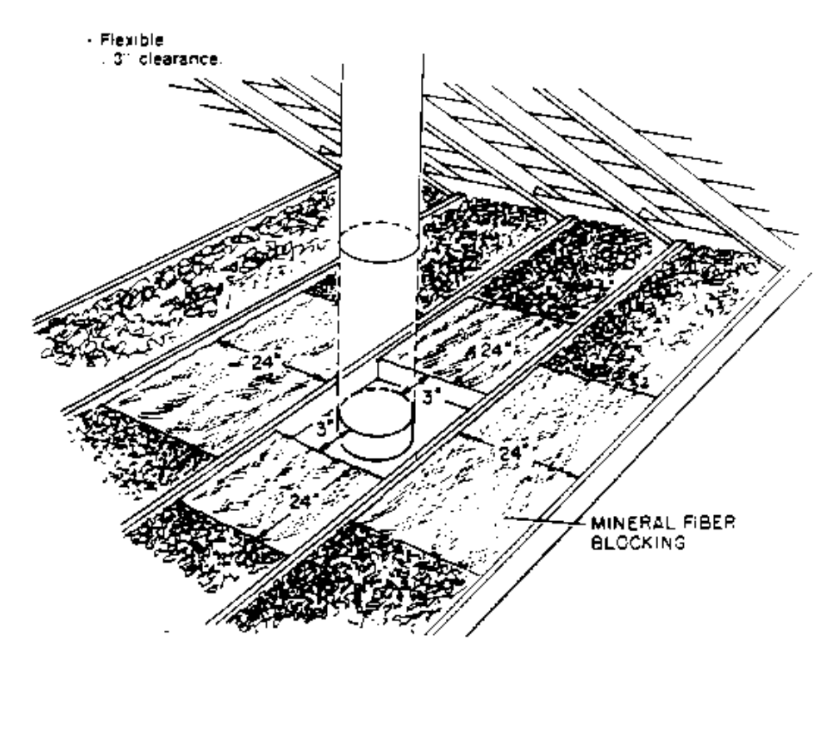
SECTION 7
ATTIC/CEILING INSULATION AND VENTILATION STANDARDS

Attic/Ceiling Insulation

ITEM | MATERIALS | CRITERIA/REQUIREMENTS
7. Blocking Installation (continued) | All materials | - Live knob and tube type wiring must not be covered, but blankets may be installed below wires if 3” clearance is maintained on top and sides
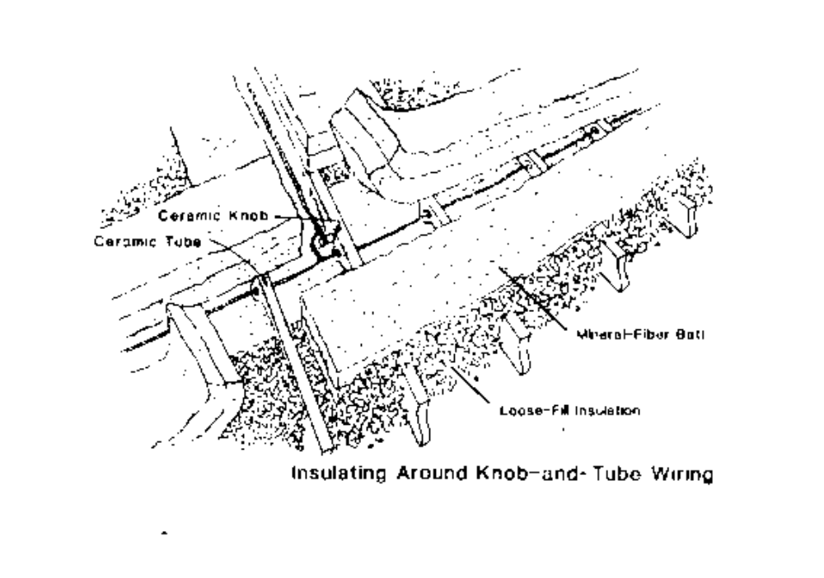
SECTION 7
ATTIC/CEILING INSULATION AND VENTILATION STANDARDS

Attic/Ceiling Insulation

ITEM | MATERIALS | CRITERIA/REQUIREMENTS
7. Blocking Installation (continued) | All materials | - Items requiring 12” minimum clearance (continued):  --heating vents (furnaces)
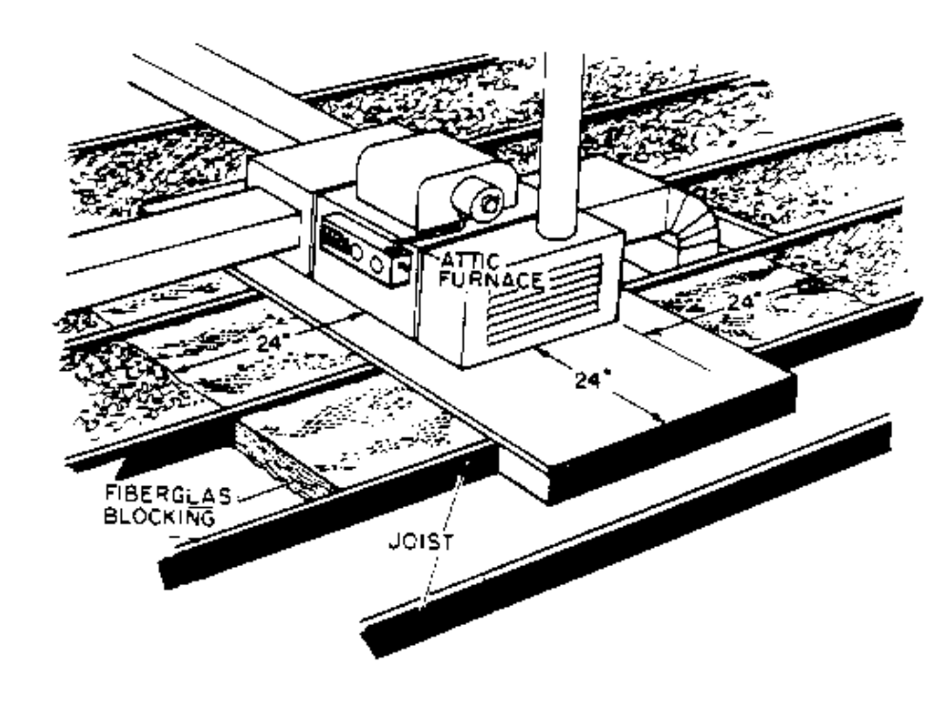
SECTION 7
ATTIC/CEILING INSULATION AND VENTILATION STANDARDS

Attic/Ceiling Insulation

ITEM | MATERIALS | CRITERIA/REQUIREMENTS
7. Blocking Installation (continued) | All materials | - Items requiring 12” minimum clearance (continued):  --water heaters (in attic)
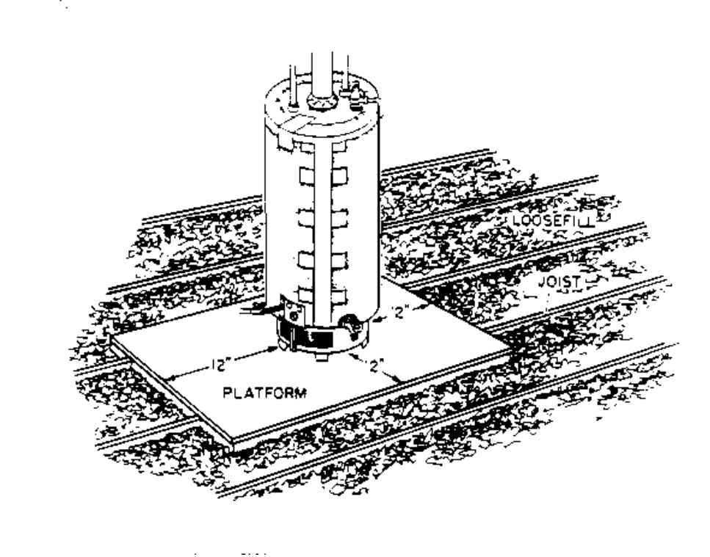
 | Loose fill | - Wood, metal or plastic blocking materials must extend at least 4” above the insulation level and must be permanently attached (stapled, nailed or screwed) to ceiling joist
 | Bat | - Mineral fiber batts when used for blocking, must be at least as high as the insulation level. (If a heat source is present, batting material should extend away from the heat source a minimum of 24” in all directions)

SECTION 7
ATTIC/CEILING INSULATION AND VENTILATION STANDARDS

Attic/Ceiling Insulation

ITEM | MATERIALS | CRITERIA/REQUIREMENTS
8. Existing Insulation Procedures | Bat | - Faced bats (with vapor barrier attached) should be installed with vapor barrier down (facing the attic floor). When installing bats over existing insulation, use unfaced bats. If unfaced bats are not available, make slashes (approximately every 6” to 8”) in the vapor barrier (to allow moisture to pass through the insulation) prior to installation. If the original bats were improperly installed (that is installed with the vapor barrier up), slash the barrier, as stated above, before new bats are installed
 | Loose fill | - When installing loose fill insulation over existing bats, address improperly installed vapor barriers in the manner outlined above
- When installing loose fill insulation over existing loose fill materials, careful attention should be paid to differing material’s densities.

- Since heavier materials will compress lighter materials (and thereby reduce their R-value and effectiveness), adherence to the following guidelines is important:
--Cellulose has the greatest density of all loose fill materials and should not be installed over existing rockwool or fiberglass
--Rockwool is heavier than fiberglass and should be installed only over existing cellulose or rockwool
--Fiberglass is the lightest of all loose fill materials and may be installed over any existing loose fill material

SECTION 7
ATTIC/CEILING INSULATION AND VENTILATION STANDARDS

Attic/Ceiling Insulation

ITEM | MATERIALS | CRITERIA/REQUIREMENTS
9. Safety Concerns | All materials | - Insulation fibers should not be inhaled. A protective air filter mask should be worn at all times
 |  | - Eyes should be protected at all times. Safety goggles should be worn when insulation is installed
 |  | - Some insulation materials can irritate the skin. Long sleeves and slacks should be worn for protection
 |  | - Remember that the attic is a cramped space filled with numerous hazards. Be careful and watch your head. There must be at least 24” clearance (between the attic floor and the roof) for insulation to be safely installed. Installers should have good lighting and adequate ventilation. Ensure that additional attic ventilation, if required, is installed prior to insulation (this will make the attic more comfortable and safer for the installer)
10. Attic Access | All types | - If existing access is difficult to enter because of size or location, it must be enlarged or sealed and relocated, preferably to an unconditioned area such as a porch or garage
 |  | - New or enlarged access should be according to CABO 1401.5 “at least 22”X30”
 |  | - Access opening should be framed on attic side by 2” x 4” or 2” x 6” members secured to adjacent joist, trimmed on ceiling side with door or window trim located to support cover equally around opening. Minimum framing height must equal height of insulation

SECTION 7
ATTIC/CEILING INSULATION AND VENTILATION STANDARDS

Attic/Ceiling Insulation

ITEM | MATERIALS | CRITERIA/REQUIREMENTS
10. Attic Access (continued) | All types (continued) | - Access located in conditioned areas must have foam tape or weather-strip installed on either the attic hatch or trim, whichever provides the most secure surface
 |  | - Accesses located in insulated areas must have R-19 insulation attached to cover
 |  | - Disappearing or folding stairs in conditioned areas must be weather-stripped
 |  | - Insulation of disappearing or folding stairs in conditioned areas is recommended by construction of an insulated surrounding box with a lightweight cover, but is not required (due to place insulation in areas under steps)
11. Vent Pipes | All types | - Must meet local codes or CABO standards
 |  | - It is recommended that operable range-vent fans be vented to the outside, when feasible, and pipes must be sealed at ceiling
 |  | - Installation of non-electric dampers in exhaust vents is recommended, but not required
 |  | - All vents extending through roofs shall have a weather resistant flashing (to prevent water leaks) and a vent cap
 |  | - Client health and safety concerns require that certain gas-fired appliances be vented to the outside atmosphere

SECTION 7
ATTIC/CEILING INSULATION AND VENTILATION STANDARDS

Attic/Ceiling Insulation

ITEM | MATERIALS | CRITERIA/REQUIREMENTS
11. Vent Pipes (continued) | Electric and Gas Water Heaters | - Pressure relief (pop off) valves must be operable and must be vented to the outside where feasible (see section 6-6 for details)
 | Gas water heaters | - Must be vented to outside using double wall pipe
 |  | - Vents must extend at least 2’ above the highest point where they pass through the roof and at least 2’ higher than any portion of the building within 10’ unless a vent cap is attached to and terminates the vent above the roof
 |  | - Vents are to be constructed so that no horizontal or negative runs or 90º angles are present
 |  | - Gas water heaters located in conditioned areas must have a metal collar installed and attached to the ceiling and sealed with silicone

SECTION 7
ATTIC/CEILING INSULATION AND VENTILATION STANDARDS

Attic/Ceiling Insulation

ITEM | MATERIALS | CRITERIA/REQUIREMENTS
12. Attic Ventilation | All types | - Sq. ft. of net free area per 200 sq. ft. of attic floor area is allowed when:  --a properly installed vapor barrier exists  --if unit is in district heating factors 1.0, 1.25 or 1.5  --If high-low venting can be achieved by positioning the vents so that 50% of the venting is “high” (in the upper 60% of the attic space) and the other 50% is “low” (in the lower 40% of the attic space)  - 1 sq. ft. of net free area per 150 sq. ft. of the attic area is required if none of the above conditions exist
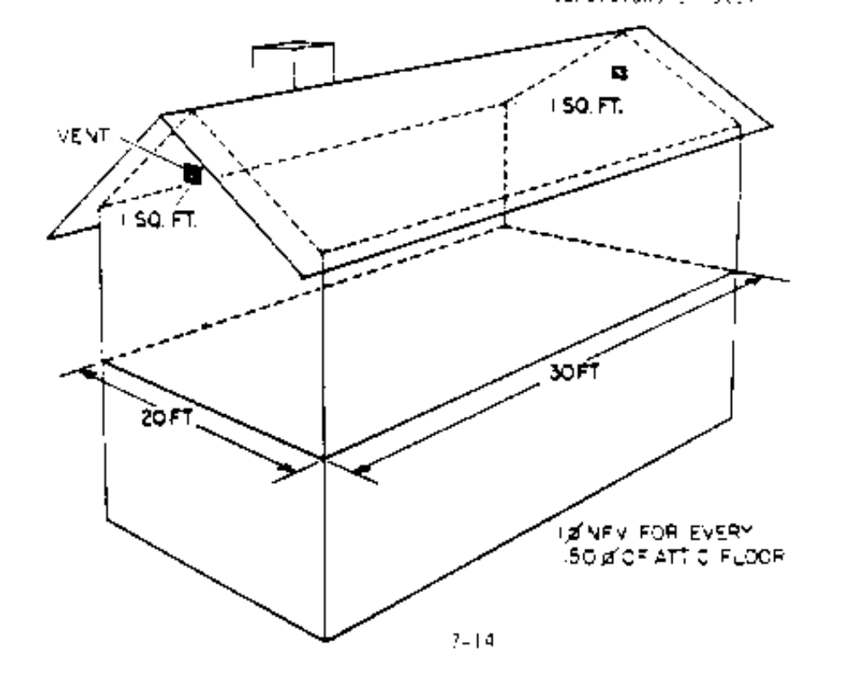
SECTION 7
ATTIC/CEILING INSULATION AND VENTILATION STANDARDS

Attic/Ceiling Insulation

ITEM | MATERIALS | CRITERIA/REQUIREMENTS
12. Attic Ventilation (continued) | All types | - Net free area or free vent opening means an opening which is not restricted by wire mesh or grill work. A vent with 1/8” or 1/4” wire mesh, for example, should be 1 1/4 times larger than the basic size. An 18” x 24” gable vent with 1/4” wire mesh would, by these calculations, count for only 2.25 sq. ft of “free venting.” A vent covered by 1/16” mesh (or 1/4” mesh and a louver) should be twice as large to meet the venting standard (i.e. 1/150 or 1/300). A vent covered by 1/16” mesh and a louver will provide only one third the free vent opening for its size
- Allowable types of vents:
--gable
--soffit
--ceiling (unconditioned areas only)
--eave
--birdboard
--static roof vent (gravity)
--ridge vent
- Note: Turbine (or wind turbine) vents are not allowed.
SECTION 8
STORM WINDOW STANDARDS

Storm Windows

ITEM | MATERIALS | CRITERIA/REQUIREMENTS
1. Allowable Materials | Window glazing | - Glass recommended
 |  | - UV and scratch resistant plastic sheets. (Polycarbonate recommended)
 | Caulking | - See caulking section (section 1) for requirements
 | Hardware and fasteners | - Shall be aluminum, stainless steel or other non-corrosive material
 | Aluminum frame | - ANSI/AAMA 1002. 10-83
 | Wood frame | - Section 3 of ANSI/NWWDA IS 2.87.
 | Rigid vinyl frame | - Interior use only
 |  | - ASTM D4099-89
2. Pre installation requirements | Prime window | - Existing units, pane, frame, and/or sash must be structurally sound
 |  | - Replace loose and/or missing glazing compound
 |  | - Contact area must be smooth and even (free of protrusions)
 |  | - Water penetration points must be sealed
 |  | - Dry rot (around contact area) must be replaced)
 |  | - Prime window panes should be wiped clean (outside for exterior or inside for interior) prior to storm window installation
SECTION 8
STORM WINDOW STANDARDS

Storm Windows

ITEM | MATERIALS | CRITERIA/REQUIREMENTS
3. Size, Shape and Opening Direction | Window | - Size, shape and opening direction (i.e. vertical or horizontal slider) must match prime window
 |  | - Applicable building code egress (guilding exit) requirements must be met
 |  | - When feasible, removable sashes should function properly (to allow cleaning with frame in place)
 |  | - No storm window shall exceed 150 United Inches
4. Glass Thickness Requirements | Frame Type & Pane  Thickness: | Maximum Pane Size (in U.I.*):
 | Wood or Aluminum - Single Strength | - Up to 100 U.I.
 | Wood or Aluminum - Double Strength (3/16” minimum) | - 101 to 150 U.I.
 | Vinyl - Double Strength | - 100 U.I. Over 100 U.I. requires vertical supports
 | Vinyl - 3/16” Minimum | - 120 U.I. Over 120 U.I. not recommended
 | Vinyl - 3/16” Minimum | - 120 U.I. Over 120 U.I. not recommended

*U.I. = United Inch = One width measurement in inches plus one length measurement in inches.
Glazing thickness must comply with local standards.
Safety glass must be used as required by local code.
SECTION 8
STORM WINDOW STANDARDS

Storm Windows

ITEM | MATERIALS | CRITERIA/REQUIREMENTS
5. Thermal Barriers Glazing Tape | Metal | - vinyl or elastomeric thermal barrier (glazing tape)
 |  | - Required to prevent metal to metal contact between storm and prime window frames
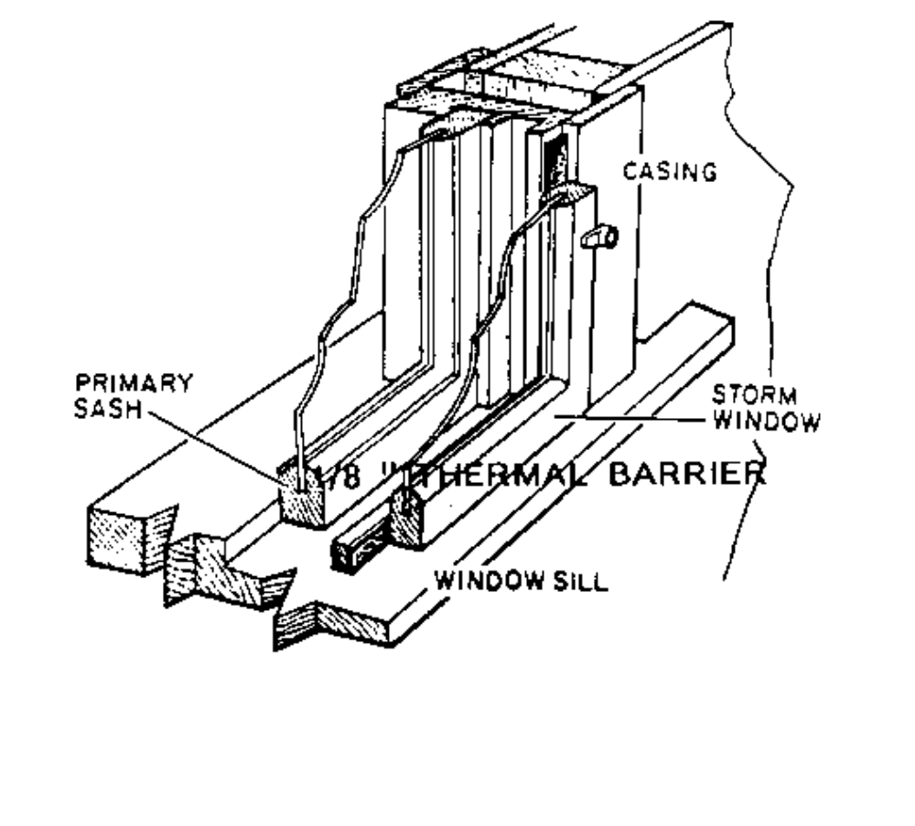

NO METAL TO METAL CONTACT

6. New (Untreated) Wood | All types | - All new, bare or untreated wood shall be sealed (with primer or water seal and stain)
SECTION 8
STORM WINDOW STANDARDS

Storm Windows

ITEM | MATERIALS | CRITERIA/REQUIREMENTS
7. Attachment | Exterior | - Must be permanently attached with screws (except drywall) or clips
 |  | - Screws must reach into structural framing member or at least 3/4” solid wood
 |  | - Must be secured within 4” of each of the four corners
 |  | - Maximum of 16” allowed between screws or clips
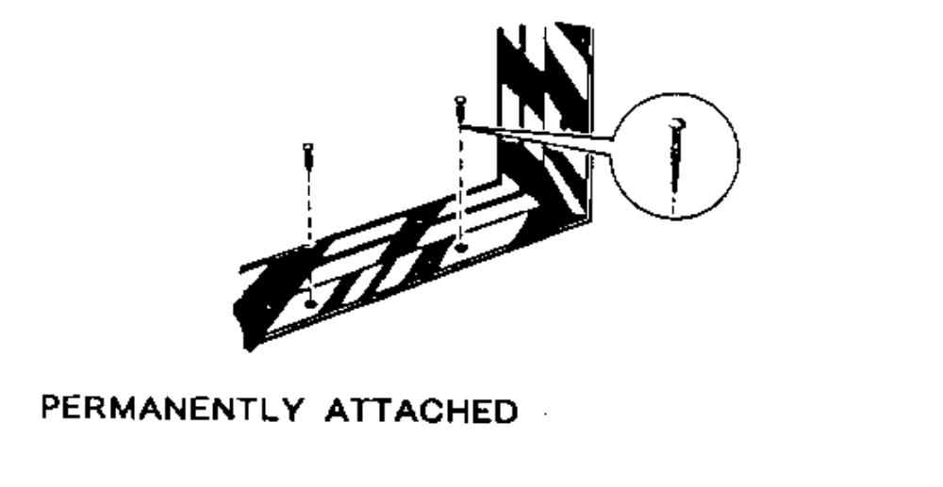

3/4” PENETRATION
4 “ FROM ALL CORNERS
16” OR LESS BETWEEN FASTENERS

SECTION 8
STORM WINDOW STANDARDS

Storm Windows

ITEM | MATERIALS | CRITERIA/REQUIREMENTS
8. Sealing | Exterior/interior | - Permanent caulking or gasket required between prime and storm window
 |  | - Seal all joints, gaps, holes and penetrations except weep holes
 |  | - No less than 2 weep holes, 3/16” diameter each, shall be provided for each exterior window (to ensure proper drainage)
9. Air Space | Exterior/interior | - to 4” between storm and prime window
10. Interior Mounting | Interior | - Mount inside existing window jamb, where possible
 |  | - Use screws or clips
 |  | - Attach as directed in #8
 |  | - Sashes must be removable
11. Sash Mounted Storm Windows | Window | - Not Allowed
12. General Operational Requirements | Permanently installed | - Operable prime windows shall remain operable without removing storm window frame
 |  | - Interior access to prime and storm window latches must not be impaired
13. General Post Installation Requirements | All material | - Storm window panes shall be wiped clean inside and outside
 |  | - All labels on storm window panes, except those required by local code, shall be removed

SECTION 9
SOLAR SCREEN STANDARDS

Solar Screens

ITEM | MATERIALS | CRITERIA/REQUIREMENTS
1. Allowable Materials | Screen/frame | - Solar screens shall be fiberglass materials in aluminum frame
 |  | - Screens must have a shading coefficient of 0.35 or lower
 |  | - Frames: 3/8” x 5/16” x .020 Center Bar: 5/16” x 5/8” x .020
2. Pre-Installation Requirements | Screen | - Install only on dwellings with operable air conditioning units or evaporative coolers
 |  | - Windows should receive at least two hours of direct sunlight per day
3. Size and Shape | Screen | - Solar screen must match prime and or storm window (or door)
4. General Installation | Screen | - All screens must be mounted with such hardware as to allow easy removal
 |  | - Bedroom windows are considered emergency fire exits under the Uniform Building Code. Solar screens shall not be installed with screws or other external hardware which prevents easy exit from inside the dwelling

SECTION 10
HEALTH AND SAFETY STANDARDS

Carbon Monoxide

ITEM | MAXIMUM LEVEL | CRITERIA/REQUIREMENTS
1. Ambient Air | 9 parts per million | - Test at initial assessment
 |  | - Test at final inspection
 | If more than 9ppm CO is detected, weatherization measures shall not be | - If above maximum level, test all combustion appliances to determine cause
 | installed until the CO problem has been corrected | - If cause cannot be determined, calibrate equipment and re-test
 |  | - If still indeterminable, refer to local gas company
2. Cook Stove Top Burners * and Un-vented Space Heaters | 25 parts per million | - Test at initial assessment
 |  | - If above maximum levels, clean and adjust burners or replace (Cook Stoves - maximum $300.00). Un-vented Space Heater replacements must have operating Oxygen Depletion Sensor System
 |  | - If funds do not allow abatement and leverage funds cannot be utilized, WALK AWAY!**
3. Cook Stove Ovens * | 150 parts per million | - Test at initial assessment
 |  | - If above maximum levels clean and adjust burner or replace (cook stove maximum $300.00)
4. Flue * | 100 parts per million | - Test all vented combustion appliances at initial assessment and final inspection
*When the CO measurement on any appliance exceeds the prescribed safe level, weatherization measures shall not be installed until the appliance has been serviced by a qualified technician and declared safe. Weatherization may proceed if CO does not exceed the prescribed level.

SECTION 10
HEALTH AND SAFETY STANDARDS

Carbon Monoxide

ITEM | MAXIMUM LEVEL | CRITERIA/REQUIREMENTS
4. Flue (continued) * |  | - If above maximum levels of CO must be abated by:  --clean and tune  --replacement  - (Contact trained personnel or licensed HVAC contractor)
 |  | - If abatement cannot be accomplished due to fund limitations, refer/leverage/or WALK AWAY**
5. Carbon Monoxide Detectors |  | - Detectors may be installed when gas appliances are in use
 |  | - Detectors should always be installed when un-vented space heaters are in use
 |  | - Detectors must meet UL Standard UL 2034-95 (Battery powered or battery backup units should not have a battery replacement cost that exceeds $3.00)

Note: Carbon Monoxide testing is to be performed with the Bacharach Monoxor II Sensor issued by the Department or an equivalent, Department approved sensing device. CO Detectors are not suitable testing devices and are not to be used. Sensing device must have a range from 0-2000 ppm; accuracy + 5% of readout; readout resolution = 1 ppm adjustable to 0; pump draw up to .75 inch of water; and an attachable probe for flue test to be considered for approval.

**Note: It is not the intent of this policy to walk away from a unit just because a high level of carbon monoxide exists. Every effort should be made to abate the existing problem. Should funds be limited, subgrantees should refer the client to another entity that can help, or attempt to find leverage funds to cover cost. All abatement procedures should be performed by trained personnel or licensed HVAC contractors. Clients should always be informed of the existence of high levels of CO and advised to take precautions until abatement can be performed. In case of a WALK AWAY, a client MUST BE INFORMED IN WRITING.

SECTION 10
HEALTH AND SAFETY STANDARDS

Excess Moisture

ITEM | SYMPTOMS | CRITERIA/REQUIREMENTS
1. Walls (interior) | Mold, Mildew | - Check unit for tightness. “Loosen” unit to upper range of DAE
 |  | - Check unit for “cold walls”. Bypass air in wall cavity will cause moisture buildup. Remedy by insulating cold wall
 |  | - Check for standing water under unit or outside sweating wall
2. Crawl Space | Standing Water | - Check for leaking plumbing or poor drainage
 |  | - Provide ventilation
 |  | - Repair plumbing/Refer
 |  | - Dam up skirting to prevent water running under unit
3. Attic | Wet Insulation (wet framing, spots on ceiling, etc.) | - Check roof for leaks  - Provide adequate venting
SECTION 10
HEALTH AND SAFETY STANDARDS

Miscellaneous

ITEM |  | CRITERIA/REQUIREMENTS
1. Gas Appliances |  | - Check for flame roll out, charring, flue condition, combustion air and gas connections
2. Woodstoves/Fireplaces |  | - Check for creosote and smoke build up, deterioration and location
3. Clothes Dryers |  | - Check gas/electric connections, venting/exhaust and lint build up
4. Electrical Wiring |  | - Visually inspect fuse box/breaker panel, junction boxes, switches, outlets, fixtures and appliances
5. Other Hazards |  | - List other hazards observed such as asbestos, lead based paint, radon, formaldehyde, etc.
6. Smoke Detectors |  | - Battery powered or Hard wired (must have a test feature, battery units must have a low battery warning feature)
 |  | - Must be UL approved

Note: Generally abatement work may be performed by WAP labor, but must comply with all local codes (CABO if applicable) and manufacturers’ instructions.
SECTION 11
Heating and Cooling Standards

The important first step in the weatherization sequence is to check the appliances for evidence of safety hazards. This section establishes the minimum standards for conducting appliance safety inspections. This document is not a how to manual. Therefore, in addition to familiarity with these standards, a working knowlege of combustion appliance safety inspection methods and equipment is required. It is vitally important to properly screen appliances for high CO, spillage and inadequate draft. Thus it is incumbent on each weatherization technician charged with that responsibility to aquire the required training and experience or to utilize the services of a trained professional.

ITEM | MATERIALS | CRITERIA/REQUIREMENTS

Central Heaters  Wall & Floor Furnace | Monoxor II  EASY Audit  ( must meet the requirements of 24 CFR 3280.707 when installed in mobile homes) | • Must be tested for Carbon Monoxide output as per Health & Safety Policy  • Must be assessed at initial  assessment, the operating  efficiency determined and entered into the EASY Audit  • Must be repaired, retrofit or replaced when indicated by an SIR of 1 or better  • Replace with high efficiency  units only: Gas heating appliances ER=.85 Electric appliances EER=10 (or better) (COP=2.9)
Unvented/Vented Space Heaters | Monoxor II  EASY Audit  ( must meet the requirements of 24 CFR 3280.707 when installed in mobile homes) | • Must be tested for Carbon Monoxide output as per  Health & Safety Policy  • Must be assessed at initial  assessment, the operating  efficiency determined and entered into the EASY Audit  - Must be repaired, retrofit or replaced when indicated by an SIR of 1 or better  • Repairs/Retrofit must reduce  CO levels to 25 ppm or less  • Replacements must have a  Factory installed Oxygen Depletion Sensor System  • Vented Space Heaters must  meet ER = .85 standards  • Electric or Kerosene space  heaters will not be allowed
ER - Energy Ratio
EER - Energy Efficiency Rating
COP - Coefficient of Performance
SECTION 11
Heating and Cooling Standards

ITEM | MATERIALS | CRITERIA/REQUIREMENTS

Central Air Conditioners | Amp Meter  ( must meet the requirements of 24 CFR 3280.714 when installed in mobile homes) | • Must be assessed at initial  assessment, the operating  efficiency determined and entered into the EASY Audit  • Must be repaired, retrofit or replaced when indicated by an SIR of 1 or better  • Replace with high efficiency  units only: EER=10)(COP=2.9)  • Must be sized to fit existing  blower units and duct systems

Whole House Window Units | Amp Meter  ( must meet the requirements of 24 CFR 3280.714 when installed in mobile homes) | • Must be assessed at initial  assessment, the operating  efficiency determined and entered into the EASY Audit  • Must be repaired, retrofit or replaced when indicated by an SIR of 1 or better  • Replace with high efficiency  units only: EER=10)(COP=2.9)  • Replace with same size unit except where smaller, more efficient unit will cool the same space

Room Air Conditioners | Amp Meter  ( must meet the requirements of 24 CFR 3280.714 when installed in mobile homes) | • Must be assessed at initial  assessment, the operating  efficiency determined and entered into the EASY Audit  • Must be repaired, retrofit or replaced when indicated by an SIR of 1 or better  • Replace with EER=10(COP=2.9)  or better  • Replace with same size unit except where smaller, more efficient unit will cool the same space (10,000 Btu Maximum)
ER - Energy Ratio
EER - Energy Efficiency Rating
COP - Coefficient of Performance
SECTION 11
Heating and Cooling Standards

ITEM | MATERIALS | CRITERIA/REQUIREMENTS

Water Heaters (CEAP Only) | • ( must meet the requirements of 24 CFR 3280.714 when installed in mobile homes) | • Must be assessed by a licensed  professional  • Must be repaired or retrofitted  where feasible  • Replace with high efficiency  units only (ER = .62+)  • Replace with same size units  except where recommended  by licensed professional  • Installation must meet all local codes (use CABO when no code exist)

ER - Energy Ratio
EER - Energy Efficiency Rating
COP - Coefficient of Performance

* All natural gas and/or propane fueled heaters must be checked to assure proper orifices have been installed to prevent cross fueling.

NOTE: According to “24 CFR PART 3280” of the Manufactured Home Construction and Safety Standards, Subpart H - Heating, Cooling and Fuel Burning Systems;

3280.707. “Heat producing appliances and vents, roof jacks and chimneys necessary for their installation in manufactured homes shall be listed or certified by a nationally recognized testing agency for use in manufactured homes.”

3280.714. “Every air conditioning unit or combination air conditioning and heating unit shall be listed or certified by a nationally recognized testing agency for the application for which the unit is intended and installed in accordance with the terms of its listing.”

SECTION 11
Heating and Cooling Standards

ITEM | MATERIALS | CRITERIA/REQUIREMENTS

Central Heaters  Wall & Floor Furnace |  | • Must be tested for Carbon Monoxide output as per Health & Safety Policy  • Must be assessed by a licensed HVAC Professional  • Must be repaired, retrofit or replaced when indicated by an SIR of 1 or better.  •Replace with high efficiency  units only:  Gas heating appliances ER=.85  Electric appliances EER=10 (or better) (COP=2.9)

Unvented/Vented Space Heaters |  | • Must be tested for Carbon Monoxide output as per  Health & Safety Policy  • Must be repaired, retrofit or replaced when indicated by an SIR of 1 or better  • Repairs/Retrofit must reduce  CO levels to 25 ppm or less  • Replacements must have a  Factory installed Oxygen Depletion Sensor System.  • Vented Space Heaters must  meet ER = .85 standards.  • Electric or Kerosene space  heaters will not be allowed

ER - Energy Ratio
EER - Energy Efficiency Rating
COP - Coefficient of Performance
SECTION 11
Heating and Cooling Standards

ITEM | MATERIALS | CRITERIA/REQUIREMENTS

Central Air Conditioners |  | • Must be assessed at initial  assessment, the operating COP  determined and entered into the EASY Audit  • Must be repaired, retrofit or replaced when indicated by an SIR of 1 or better  • Replace with high efficiency  units only: EER=10)(COP=2.9)  • Must be sized to fit existing  blower units and duct systems

Whole House Window Units |  | • Must be assessed by a  licensed HVAC Professional  • Must be repaired, retrofit or replaced when indicated by an SIR of 1 or better  • Replace with high efficiency  units only: EER=10)(COP=2.9)  • Replace with same size unit except where smaller, more efficient unit will cool the same space.

Room Air Conditioners |  | • Must be assessed by a  licensed HVAC Professional  • Must be repaired, retrofit or replaced when indicated by an SIR of 1 or better  • Replace with EER=10(COP=2.9)  or better.  • Replace with same size unit except where smaller, more efficient unit will cool the same space. (10,000 Btu Maximum)

ER - Energy Ratio
EER - Energy Efficiency Rating
COP - Coefficient of Performance
SECTION 11
Heating and Cooling Standards

ITEM | MATERIALS | CRITERIA/REQUIREMENTS

Water Heaters (CEAP Only) |  | • Must be assessed by a licensed  professional.  • Must be repaired or retrofitted  where feasible.  • Replace with high efficiency  units only (ER = .62)  • Replace with same size units  except where recommended  by licensed professional  • Installation must meet all local  codes. (use CABO when no code exist)

ER - Energy Ratio
EER - Energy Efficiency Rating
COP - Coefficient of Performance

* All natural gas and/or propane fueled heaters must be checked to assure proper orfices have been installed to prevent cross fueling.

NOTE: According to “PART 3280” of the Manufactured Home Construction and Safety Standards,Subpart H - Heating, Cooling ang Fuel Burning Systems;

Section 12
Wall Insulation Standards

Item | Material | Criteria/Requirements

1. Allowable Materials | Mineral Fiber  - Fiberglass  - Rock Wool  Cellulose  - Loose Fill | - Batts only  Conforms to ASTM C665-  88. Must have vapor barrier  facing warm side  - Batts Only  Must have vapor barrier  facing warm side  - Conforms to ASTM  C764-88
2. R- Values | All Materials | - R-11 Minimum (Overall  R-Value that includes  interior and exterior  sheathing and siding must  be a minimum of R-15)
3. Dense Pack | Cellulose Only  - Tube Fill Method | - Insulation shall be installed  at a minimum weight of 3.4  lb. per cubic foot  - Cavities less than 3’ in height or where it is not possible to tube fill may be insulated using the two hole method
- 4. Loose Fill | Cellulose or Fiberglass  - Two Hole Method | - Side wall cavities shall be checked for obstructions prior to insulating the cavity  - Entry holes shall be properly sized for the type of insulation being installed  - Entry holes shall be placed no lower that 1’ from the top plate and no higher than 48’ from the bottom plate

5. Repair | All Materials | - Interior and Exterior walls shall be repaired prior to insulating the wall cavity  - All repairs shall be durable and permanent

Section 12
Wall Insulation Standards
(Continued)
Item | Material | Criteria/Requirements

6. Siding Removal | All Materials | - Siding that has been removed shall be reinstalled using the original system.  - Slate, vinyl, steel or aluminum siding that has been removed shall have the entry holes sealed with a plastic or wood plug or covered with felt prior to reinstalling siding  - Siding that may contain asbestos may be removed so long as the siding material remains intact. Removal shall comply with State and local regulations
7. Entry Holes | Cellulose/Fiberglass | - In every stud cavity  - Exterior holes in wood siding shall be sealed with plastic or wood plugs and painted to match siding  - Exterior holes in masonry or stucco siding shall be sealed with a mortar or a material specifically manufactured to repair stucco or masonry  - Mortar shall completely seal the opening and be textured and painted, if necessary, to match the surrounding surface  - Interior holes in drywall shall be plugged and taped or sealed with a material specifically manufactured to repair drywall or plaster. Holes shall be made ready for paint

- Interior holes in plywood, chipboard or hardboard shall be plugged and sealed with caulk

Section 12
Wall Insulation Standards
(continued)
Item | Material | Criteria/Requirements

8. Single Wall Construction | Fiberglass/Rockwool Batts | - Shall be install with Kraft side(vapor barrier) facing the warm side  - Shall be covered with sheetrock, plywood, chipboard or hardboard  - Drywall shall be taped and receive at least one coat of joint compound  - Plywood, Chipboard or hardboard joints shall be caulked. Note: drywall, plywood, chipboard or hardboard shall not be installed in areas exposed to the weather or to high moisture
9. Nonfeasible | All Materials | Do not insulate:
- Partially insulated cavities
- Cavities serving as HVAC ducts
- Cavities with wall heaters
- Cavities with operating knob and tube wiring
- Walls with leaks or unrepaired damage
- Interior or exterior walls with substandard sheathing

Section 13
Floor Insulation Standards

Item | Material | Criteria/Requirements

1. Allowable Materials | Mineral Fiber  - Rockwool Batts  - Fiberglass Batts  - Loose Fill  ( Fiberglass, Rockwool or Cellulose) | - Must meet or exceed ASTM C665-88  - Must meet or exceed ASTM C665-88  - Mobile Home Belly Blow Only  - Must meet ASTM C764-88
2. Recommended Installation  - Site Built Pier and Beam  - Mobile Homes | - Fiberglass/Rockwool Batts  - Loose Fill  ( Fiberglass, Rockwool or Cellulose)  - Fiberglass/Rockwool Batts  - Loose Fill  ( Fiberglass, Rockwool or Cellulose) | - Kraft faced vapor barrier must face warm side (up)  - Must be sized to fit space between floor joist  - Retainers or straps must be used to hold batts permanently in place  - All bypasses must be sealed  - Not acceptable  - Kraft faced vapor barrier must face warm side (up)  - Must be sized to fit space between floor joist  - Retainers or straps must be used to hold batts permanently in place  - All bypasses must be sealed  - Belly Board or industry accepted rodent barrier must be repaired or replaced  Belly Board Penetration  - Preferred in all cases  - Required to insulate all interior areas not accessible through rim joist  Rim Joist Penetration  - Acceptable when joist size and condition allow for safe and proper installation  - May be used to insulate joist cavities or portions of cavities which have unobstructed access from the outside perimeter  - Penetration points shall be those most feasible  - A combination of belly and joist penetrations may be used to achieve optimum results

Section 13
Floor Insulation Standards

Item | Material | Criteria/Requirements
(Continued)
- Coverage |  | - All areas not occupied by ducts, plenums or other obstructions shall be insulated  - R-Value shall be a minimum  R-15  - The cavity beneath an appliance enclosure which has combustion air venting shall not be insulated unless the venting is ducted through the belly board
- Access Holes  Rim Joist Access  Hole Location  Belly Injection | End and Side Joist | - Bottom wall trim shall be removed to expose the rim joist  - Exterior siding may be unfastened only if necessary  - Rim Joist access shall be considered NOT feasible if it will result in visible damage to the siding  - One hole for each joist cavity  - Centered on joist to minimize structural damage  - Care shall be exercised to avoid damage to plumbing/electrical lines attached to or adjacent to rim joist  - Penetrations shall be made as needed to achieve complete coverage  - Holes cut for inspection and existing damage holes may be used for access  - Holes shall be of sufficient size and spacing to accommodate the directional nozzle or fill tube utilized  - Maximum insulation travel beyond the nozzle or fill tube shall be 2’

